|  |  |
| --- | --- |
|  | **2016** |
|  | De Montfort University  Aaron Edwards (P12195501) – BSc Artificial Intelligence with Robotics |

|  |
| --- |
| **[Mobile Robotics – Implementation of a robot controller]** Abstract: |
| A controller for a mobile robot is proposed, developed and reviewed. This project utilises the ARIA library and MobileSim software to create a simulation for the proposed controller, it is this simulation that is used for testing and evaluation purposes. The relevant literature is used to help refine the proposed design, resulting in a Subsumption Architecture implementing several behaviours. These include Obstacle Avoidance – which was implemented using Potential Fields, Edge Following – which used a Feedback Controller, Random Wandering – which again used Potential Fields by proxy, and Environment Mapping – which made use of the Modified Histogram method. These behaviours provided a very robust and capable controller that allowed the simulated robot to perform each task very well. |

Contents

Abstract: 0

Introduction: 2

Background: 2

ARIA: 2

Control Architectures: 2

Classical Control: 2

Subsumption: 3

Fundamental Behaviours: 3

Obstacle Avoidance: 3

The Bug Algorithm: 3

Potential Fields: 3

Edge Following: 4

Feedback Control: 4

Fuzzy Logic: 5

Wandering/Exploration: 5

Localisation/Dead Reckoning: 5

Odometry: 6

Mapping: 6

Modified Histogram Technique: 6

Scattergrams/RANSAC: 7

Path Planning: 7

A*: 7

Meadow Map Method: 8

Concluded Design: 8

Implementation/Approach to Problem: 9

Software Architecture: 9

Obstacle Avoidance: 9

Edge Following: 10

Wandering/Exploration: 11

Mapping: 12

Performance Review: 13

Testing: 14

Edge Following: 14

Conclusion: 14

Bibliography: 15

Appendices: 17

Control Architectures: 17

Test Maps: 17

Obstacle Avoidance: 19

Edge Following: 20

Wandering: 21

Mapping: 22

# Introduction:

The purpose of this report is to propose a possible solution for the problem of having a mobile robot operate in an unknown environment, attempting to navigate through this environment to the other end. This problem will be simulated using ARIA *(Advanced Robotic Interface for Applications)* for prototyping simplicity. Several fundamental behaviours must be exhibited by the proposed controller; Obstacle Avoidance, Edge Following, Random wandering and either Path Planning or Environment Mapping. At least one of these behaviours must utilise a Feedback Control method. The project specification also specifies that the robot may not come within 250mm of an obstacle. The following report seeks to provide background information on the task at hand, the relevant pre-existing literature will then be reviewed to help ensure that the proposed design is as effective as possible, finally a critical review of the performance of the proposed system will be given along with the results of any experiments / tests.

# Background:

## ARIA:

The Advanced Robotics Interface for Applications was designed to provide an API for the MobileSim robotic simulator[1]. This software allows developers to develop behaviours for robotic platforms without having to write a robotics library from scratch. ARIA handles all of the lower levels and core functionalities that would be expected from a robotics library, including support for network communication and multi-threading / parallel processing[1]. This makes ARIA a very powerful tool for prototyping, as the developer can afford to spend more time working on their own behaviours and routines. ARIA has some very good support for implementing Behavioural Architectures on the simulated robots, including providing support for Subsumption Architectures[1]. Furthermore the code written for ARIA can be easily ported to the Pioneer range of robots, as the robot used in ARIA is a simulated version of the Pioneer 3 robot that was developed for research purposes[1], [2], this means that behaviours can easily be tested and demonstrated on physical robotic hardware easily.

When ARIA is used in conjunction with the MobileSim software, the user is able to monitor any simulations in real time. The user is given a 2D, top-down visual representation of the robot, the route the robot has followed, its environment and the “visible range” of its sensors *(see figure below)*.

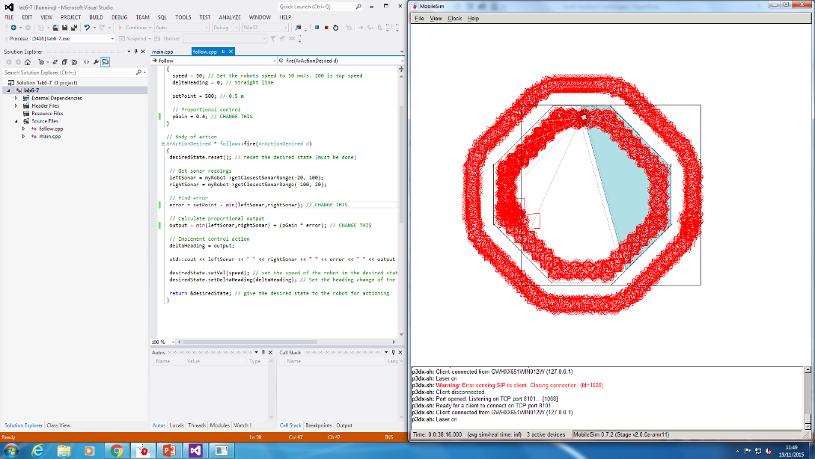

Figure 1 - Example of PID Edge Following using ARIA / MobileSim

# Control Architectures:

## Classical Control:

Classical control methods follow the Model-View-Controller (MVC) paradigm from Software Development; this means that the program follows the pattern of Take Input -> Decide What Action To Take -> Take Action [3]. A Finite State Machine (FSM) can be seen as a form of Classical Control, as the process flow of an FSM follows the same paradigm [4]. This control structure is not optimal for mobile robotics; as there is a relatively large time between input into the system and any output being observed on the robot[3]***.*** This control structure also struggles to enable a system to carry out more than one task at a time; the only way to do this in a FSM would be to have each and every state take all necessary inputs for every other state, and process transitions between them all. This is clearly not a solution that is very scalable at all; the complexity of such a controller would make emergent behaviours and software bugs almost certain. Additionally this solution would be prohibitively inefficient, both in terms of development time and computationally. This control architecture will not be implemented for this project, for the reasons previously stated.

## Subsumption:

The Subsumption Architecture is a reactive control architecture [5], this means that this architecture is particularly good at reacting to the robot’s environment [3]. This is done by splitting the controller into a series of “levels of competence”[5], each of which is processed in parallel. *“Each level of competence represents a complete, working behavior which the robot can successfully execute”*[5]. Each behaviour interacts directly with the environment by subsuming control (hence the name) of the robot from behaviours with a lower priority [3], [5], [6] *(see Subsumption section of appendix)*. There are some downsides to this approach to control architectures; using this method code duplication is more prominent [5], behaviours cannot be combines with one another [3], and the “Arbiter” (the section of code that is used to decide which behaviour should run at any time) must be evaluated and hard-written at design time[7]. Additionally it can be difficult to write the Arbiter in such a way that encourages the correct behaviours to run reliably without any emergent behaviours occurring in other instances. However this point is not relevant to this project; as the Subsumption architecture control system is a pre-existing module of ARIA, so only the behaviours need to be written. Due to the fact that a Subsumption architecture provides a good, robust and easily scalable control architecture for mobile robots [5], and the fact that the Subsumption architecture is the de-facto controller used in ARIA, this is the software architecture that will be used for the controller in this project.

# Fundamental Behaviours:

## Obstacle Avoidance:

### The Bug Algorithm:

This is possibly the simplest obstacle avoidance algorithm [8]. It can work with either a final desired destination, or without [8]. In essence this algorithm sets up a threshold for the range sensors, if an obstacle is detected within that threshold the robot turns and follows the outline of the obstacle until the robot has a clear path to its destination. If the robot does not have a destination then the robot simply turns away [8]. This algorithm is very lightweight and simple, which makes obstacle avoidance a computationally efficient behaviour. However due to the level of simplicity this algorithm will not be utilised for the obstacle avoidance behaviour.

### Potential Fields:

An algorithm that utilises a higher level of deliberative computation is the Potential Fields algorithm; this algorithm’s obstacle avoidance can be seen as a sub-behaviour of its path planning behaviour [8]. The potential field’s theory for obstacle avoidance and environment navigation is based on field physics, specifically this technology mimics our observations of magnetic fields [9]. This technology implements the inverse square rule to convert the readings taken from the robot’s range sensors into a simulated force acting on the robot *(see figure below)*[9]–[11]. This is done using the inverse square rule, as taken from the observations of objects within magnetic and gravitational fields [9], [10]. These simulated forces can be either repulsive or attractive, based on whether the field is being created on an obstacle to avoid, or a goal for the robot to navigate to *(see equations below)*. By collating the sum of these fields, the robot is able to navigate to its goal while avoiding obstacles. Note that this method does not need a goal in order for the robot to avoid obstacles.

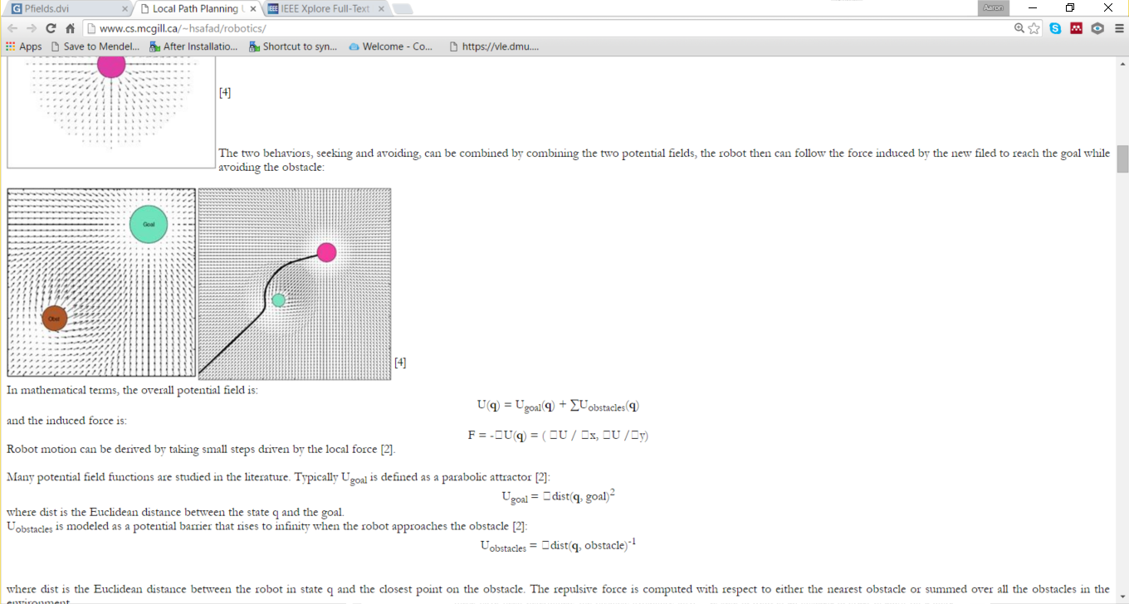

Figure 2 - Potential Fields Diagram (taken from http://phoenix.goucher.edu/~jillz/cs325_robotics/goodrich_potential_fields.pdf)

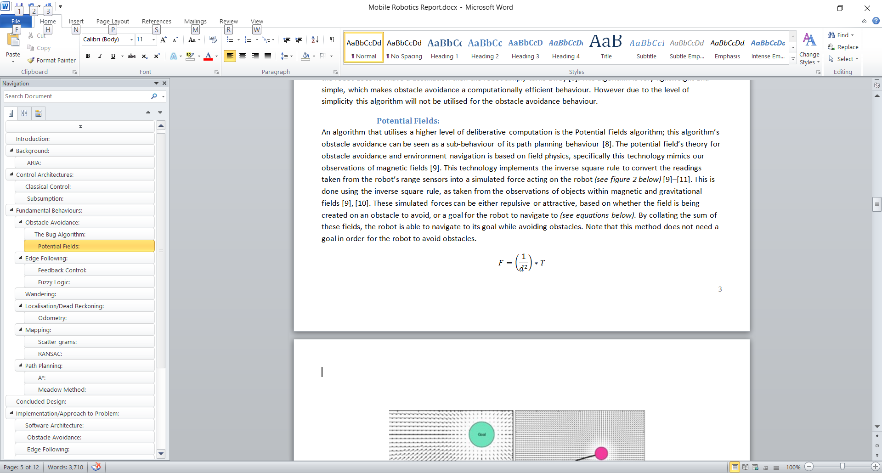

Equation 1- Obstacle Repulsion Field

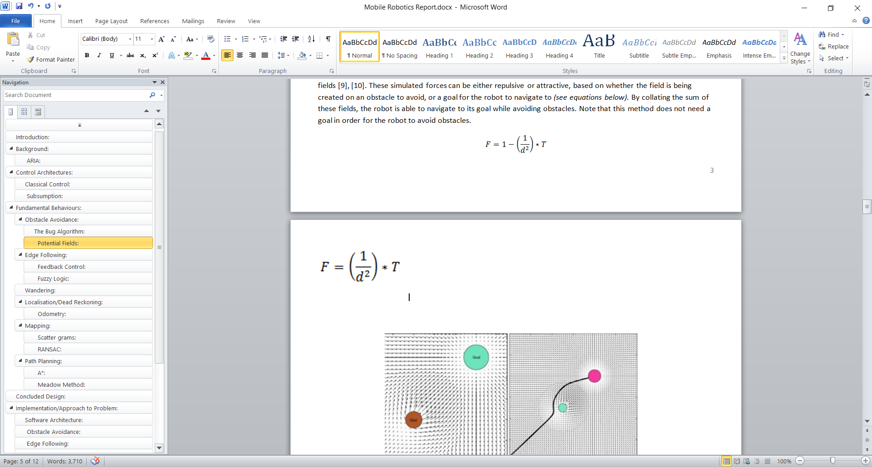

Equation 2- Goal Attraction Field

This technology is a very good example of obstacle avoidance; it is relatively computationally light, it enables the robot to avoid local minimum or “dead-ends” and with the addition of a goal for the robot it enables a certain level of reactive path planning [9]–[11]. This method of obstacle avoidance also incorporates a more intelligent method by which the speed of the robot can be controlled [10], compared to other methods that simply correlate the speed of the robot to the range of the closest obstacle. It should be noted that this method does not find the optimal route for a robot to take [11], and often the resulting path can be considered more “the path of least resistance” rather than the shortest route from the robot’s starting position to its goal. If this technology were to be developed so that, given a known map of the environment, the robot could pre-process this algorithm and find a “path of least resistance” to follow. This path could then be split up and passed off to a Topological algorithm to help the robot to navigate to each waypoint successively [12], [13]. This would not provide the optimal route for the robot, but may provide the most convenient path.

Potential Fields obstacle avoidance may be implemented for this project, as it gives a good level of reactive capability, it’s computationally efficient enough that this behaviour would not have a negative impact on the speed of the system as a whole and if the implementation includes a goal for the robot to travel to, this approach gives the robot a certain level of path planning. Please note that this level of path planning does not fulfil the project brief for the path planning behaviour, as that behaviour must have more of a Heuristic approach that takes the complete map as an input and outputs a complete path for the robot to follow. However the Topological Potential Fields offshoot that was spoken about earlier in this section would suffice as a path planning algorithm. This may be implemented depending on whether the relevant literature that is to be reviewed suggests an alternative method that would provide a better solution.

## Edge Following:

### Feedback Control:

Feedback Controllers are common place in automated control systems that require fast, reliable and relatively accurate responses [14]. As far as these controllers are concerned, all control problems can be boiled down to three basic sections; *“The most elementary feedback control system has three components: a plant (the object to be controlled, no matter what it is, is always called the plant), a sensor to measure the output of the plant, and a controller to generate the plant’s input.”* [15]. In essence this means that any simple control problem can be solved using three simple elements; the system input, the feedback controller itself, and the output signal [14], [15]. This suggests that any control problem that requires simplicity and computational efficiency would be ideal for Feedback Control, provided that the system in question provides some quantifiable output for the system to use.

The most predominant form of Feedback Control is the PID *(Proportional, Integral, Derivative)* controller, this simple controller takes the output of the system and uses it to analyse how well the system is working, this is then used to help correct any error in the system [16], [17] *(see figure below)*.

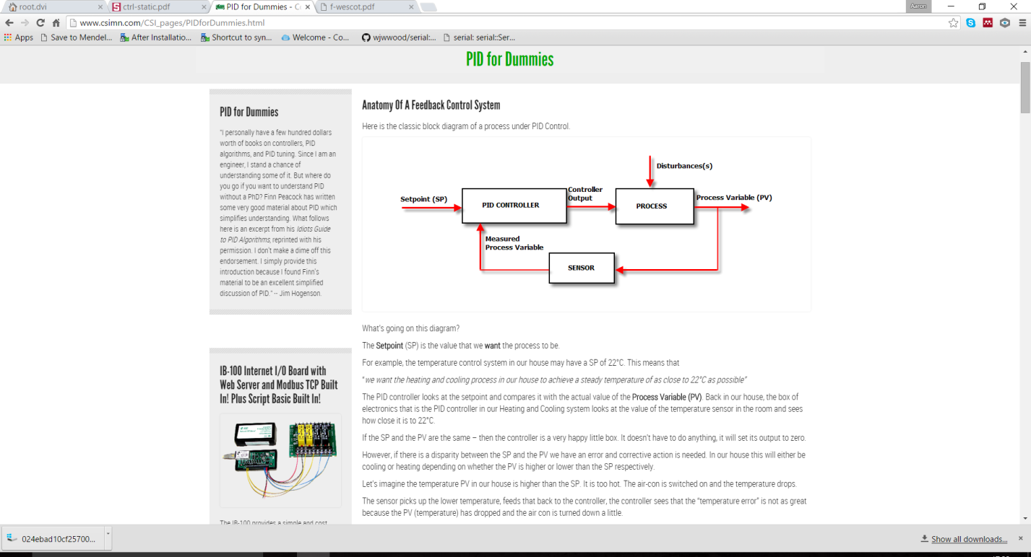

Figure 3 – PID Diagram (Taken from http://ctms.engin.umich.edu/CTMS/index.php?example=Introduction&section=ControlPID)

The PID controller is built up of three separate sub-systems, each of these sub-systems perform a different calculation on the system and each of these have a different purpose, that when combined provide a robust and versatile control system [16]–[18]. The Proportional Controller works by analysing the amount of error in the system *(this is calculated by quantifying how far the system is operating from its pre-defined set point)*. The Proportional controller changes the output of the system such that the amount of error is reduced as fast as possible; the output of the system is directly *Proportional* to the amount of error in that system, hence the name. A Proportional controller alone does not provide a very stable solution; in trying to arrive at the set point so fast these systems often overshoot and oscillate about the set point *(see Edge Following section of appendix)*. In order to help dampen this oscillation the Derivative Controller works by looking at the rate of change of the error in the system [16], [17] *(hence the name Derivative)* this means that the further the system is from its set point, the higher the rate of change of the system [16], [17]. Therefore the closer the system is to the set point, the slower the Derivative controller allows the system to approach the set point. This helps reduce oscillation and smooth out the output signal, providing a more stable solution. Finally the Integral Controller helps stabilise the system as a whole by accounting for long term errors, usually caused by inputs to the system that are external to the controller [17]. These are often environmental issues, such as flat tyres of cars etc. The Integral controller works by looking at all the previous errors of the system and therefore provides a positive or negative bias to the calculation based on that [16], [17]. Since this project is using a simulator, there are no external errors to account for; therefore an Integral controller will not be included. However a PD *(Proportional, Derivative)* controller will be implemented for the behaviour of Edge Following, this is due to the fact that Feedback controllers are very computationally efficient and robust and based on the relevant literature PID controllers are very popular for this type of control problem.

### Fuzzy Logic:

Fuzzy Logic is a viable alternative to Feedback Control for the problem of Edge Following; Fuzzy Logic Controllers *(FLC)* provide an effective solution for problems such as navigation [19]. However where the Mamdani controller in the given example [19] had issues borne of contradictory rules and poor transitions between Fuzzy Sets, a TSK Fuzzy Logic Controller would be less likely to face the same issues. This is due to the fact that a TSK system typically has a less rich Knowledge Base [20]. This also greatly improves the computational efficiency of the TSK system, compared to the Mamdani system. A TSK system could be used to Edge Follow; the Antecedents could be the distance from the detected edge and the angle of the detected edge, relative to the robot. The Consequent would be the angle by which the robot should turn. The use of a FLC for this problem would reduce the amount of training/tuning that would be needed. However a rule base would need to be defined. Due to the fact that this method would be less computationally efficient than a PID controller, and the fact that this method would not be as simple to implement, this method will not be used to create a controller for this behaviour.

## Wandering/Exploration:

Exploration / Random Wandering is a fairly common behaviour in mobile robotics; it allows a robot the possibility of discovering new areas that were previously unexplored. This can provide benefits to robots whose purpose is environment mapping, search and rescue, or anything else that would benefit from a small amount of controlled unpredictability. Quite often this behaviour combined with a level of obstacle avoidance and environment mapping [21]–[23]. However these elements are unnecessary for this implementation, as these could potentially clash with the robot’s other behaviours. Therefore as opposed to implementing a method such as those suggested by the literature, various aspects of these ideas may be implemented such that this behaviour works in conjunction with the robot’s other behaviours. Using an obstacle avoidance or path planning behaviour that results in the robot trying to reach a pre-defined goal could be used as a means to explore an environment without running the risk of having emergent behaviours arise [22]. In this way the Wander behaviour would effectively become a sub-controller for the Obstacle Avoidance / Path Planning behaviour; the Wander behaviour would simply set a new goal for the robot to travel to, thus causing the robot to explore a potentially unexplored area. Having looked at the literature on this topic, a method such as this seems to be fairly effective. However the norm seems to be including the Wander/Exploration into the Obstacle Avoidance layer [22]. This is where the method that will be implemented for this project differs; this approach will abstract the Wander out into a separate behaviour that is to use either the Obstacle Avoidance or Path Planning behaviour as a proxy to enable to robot to wander to new areas. In order for this to work, either the obstacle avoidance will need to utilise a method that includes some level of reactive path planning, or a full heuristic path planning behaviour will be needed.

## Localisation/Dead Reckoning:

While ARIA has inbuilt support for finding the robot’s position [2], various localisation and dead reckoning technologies will be researched and if a solution that is sufficiently accurate and depending on the amount of time it would take to implement such a behaviour, a localisation behaviour may be included as part of this project. This would enable the code to be taken from the MobileSim simulation and ported over to a Pioneer robot for real world demonstration. Localisation technologies are a series of algorithms that are concerned with keeping track of a robot’s current position and heading, relative to its starting location[24], [25]. There are a large number of algorithms that utilise this, with varying levels of complexity, efficiency and success.

### Odometry:

Perhaps the simplest form of localisation/dead reckoning is Odometry; this technology uses information gathered from encoders on the wheels of the robot, along with known quantities about the robot *(such as wheel radius and the distance between the robot’s wheels etc.)*, to calculate how far each wheel has rotated per control cycle *(see equation below)*. From this the amount the robot has moved in both the *X* and *Y* axis can be calculated, along with any changes to the robot’s heading. Note that Odometry is designed for robots that utilise differential drive [25]–[27].

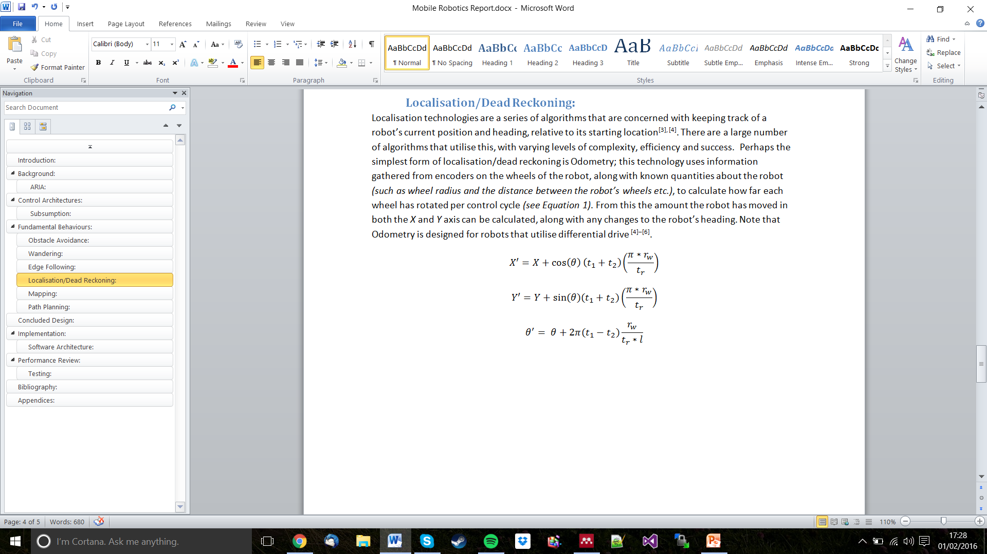

Equation 3 - Odometry Equations

Odometry is a very good technology to use, as it is computationally lightweight and can provide a reasonably accurate representation of the robot’s current position and heading. However there is a certain level of error that accumulates in this system. This is due to the fact that the encoders on the wheels can only be so accurate, and any amount of slippage that occurs on either wheel will not be taken into account in the system [25], [27]. Therefore, given enough time the robot’s idea of where it is in the environment will become less and less accurate. There is one method that improves the accuracy of the Odometric model; this is done by using a more accurate Kinematic data model in the calculations *(see equation below)* [26]. For the purpose of this project, the standard form of Odometry can be considered an appropriate solution; while this is less accurate than its more complex variant, the level of inherent error that is included in the ARIA/MobileSim simulation is remarkably lower than a real robot would experience. For example robots in the simulation do not experience wheel slippage during turning. This means that the extra complexity of implementing the more advanced localisation method is unnecessary.

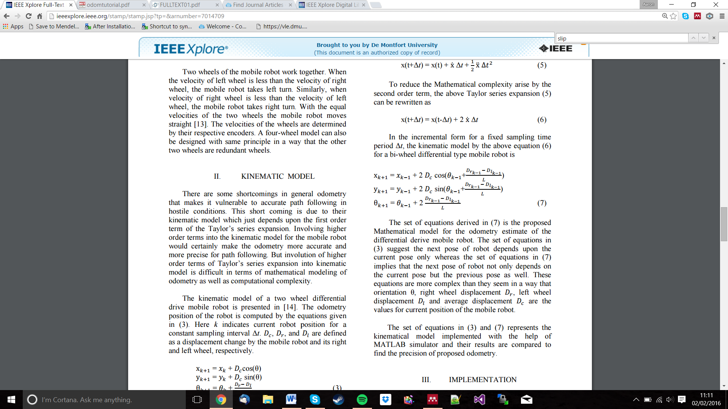

Equation 4 - Odometry Equations using updated Kinematic Model (taken from http://ieeexplore.ieee.org/xpl/articleDetails.jsp?arnumber=7014709)

## Mapping:

### Modified Histogram Technique:

One major problem in the field of environment mapping is the level of inaccuracy involved; *“The accurate environment mapping depends on how well robot perceives environment, and how precise is its location. It is well known that perceptually acquired information is usually unreliable and there are uncertainties in sensor measurements.”* [28] This shows us that simply recording readings from range sensors and displaying them in global space is inadequate, even in a simulator like Aria that has very accurate localisation technology built in. This particular method is an offshoot of Borenstein’s histogramic in - motion obstacle avoidance technique, whereby the map updating has been further developed [28][29]. This particular approach to improved mapping focuses on two areas; improving the reliability of the kinematic and odometric models on the robot *(and therefore improving the accuracy of the map, as this is dependent on the robot knowing its location)* the mapping algorithm itself is also an obvious area of focus in this paper [28]. This method involves using a occupancy grid to provide a measure of certainty that a particular location is occupied, this can also be done by using methods such as Bayesian Probability or Fuzzy Logic [28]. At a high level this method follows the following steps:

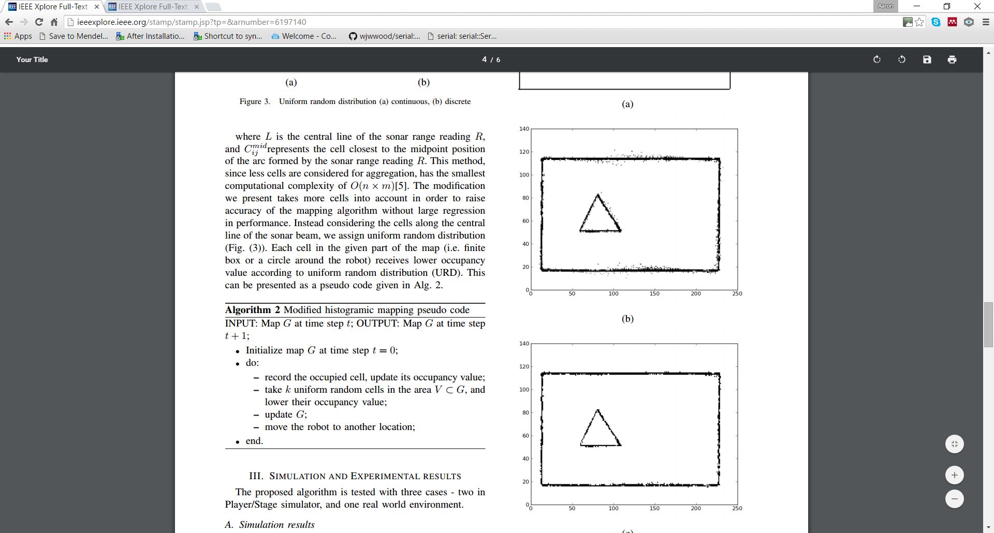

Figure 4 - Mapping Algorithm Pseudo Code (taken from http://ieeexplore.ieee.org/stamp/stamp.jsp?tp=&arnumber=6197140)

According to the literature, this method provides a very good result. However certain aspects of this would need to be altered slightly to work better with the Aria simulator; for example the resolution of the occupancy grid would have to be reduced to make the behaviour more efficient. In addition the section of this method that works on improving the robot’s localisation model is unnecessary, this is because Aria’s own in built system works very well to begin with. This method of path planning would make a very good addition to this project, as it provides a fairly robust mapping method that includes a method of reducing the amount of noise / error in the resultant map.

Though it doesn’t specify in the pseudo code above, the process by which an occupied cell is detected is by rotating and translating the position of a detected obstacle from local space *(relative to the robot)* to global space *(relative to the robot’s starting position – 0, 0, 0 in x, y, ϑ respectively)*. This is done by using the equations below:

$$Rotation: \begin{matrix}X_{L} \\ Y_{L}\end{matrix}=\left[\begin{matrix}cosθ & -sinθ \\ sinθ & cosθ\end{matrix}\right]*\begin{matrix}X \\ Y\end{matrix}$$

Where XL, YL are the X and Y co-ordinates in local space respectively, *ϑ* is the angle of the obstacle relative to the robot and X, Y are the robot’s current X and Y co-ordinated respectively.

$$Translation: \begin{matrix}X_{G} \\ Y_{G}\end{matrix}= \left[\begin{matrix}X_{L}*cosθ & Y_{L}* -sinθ \\ Y_{L}*sinθ & Y_{L}*sinθ\end{matrix}\right]+ \begin{matrix}X_{R} \\ X_{R}\end{matrix}$$

Where XG, YG are the obstacle’s X and Y co-ordinated in global space respectively, XL, YG are the obstacle’s X and Y co-ordinates in local space respectively, *ϑ* is the robot’s current heading in global space and XR, YR are the robot’s X and Y co-ordinates in global space respectively.

In all Histogram / Scattergram mapping methods, the location of the obstacles and the robot are stored in global space, so that all locations are relative to the robot’s starting position 0, 0, 0.

### Scattergrams/RANSAC:

The Random Sampling and Consensus *(RANSAC)* algorithm is another method of trying to improve the accuracy of a robot’s mapping data. *“RANSAC is a resampling technique that generates candidate solutions by using the minimum number observations (data points) required to estimate the underlying model parameters.”* [30]. This means that this algorithm is suited to environments, such as environment mapping, that have a large amount of uncertainty in the input data. Due to its ability to produce trends out of less accurate data, RANSAC is often used to help improve the output of less accurate mapping technologies, such as Scattergram mapping. This approach to mapping will only be undertaken if there is not sufficient time to implement the Modified Histogram Technique. This is because, even after running the RANSAC algorithm to improve the accuracy of the output data, this method provides a less reliable map than the Histogram Technique [28], [30].

## Path Planning:

### A*:

A* Heuristic path planning works on a pre-defined map, splitting the map into a grid and then analysing each cell, based on how far the robot must move to reach that cell and how far it must still go to reach its goal [31]. This algorithm helps to give the robot a grid based path that can be considered optimal; i.e. the solution it provides is the shortest possible path from the robot’s starting position to its goal [31]. Naturally this algorithm requires a complete representation of the robot’s map to be available on start-up. One weakness that is inherent in all Path Planning algorithms that require prior knowledge of the map is that they do not, in and of themselves, account for the possibility that the environment may have changed, or the map may be somewhat inaccurate to begin with. This could potentially lead to the robot failing to find its objective or colliding with unforeseen obstacles etc. However in a reactive controller, such as a Subsumption, other behaviours such as Obstacle Avoidance would take control of the robot in the eventuality that the robot is likely to collide with an obstacle. This algorithm will likely not be included in the implementation of this project, due to the high level of computation required. It would be very difficult to provide an implementation that would conform to the 10Hz cycle speed of the Aria programme.

### Meadow Map Method:

The Meadow Map method *(also known as hybrid vertex-graph free-space model)* [32] works by dividing the map *(also known as the Configuration Space)* [32] into a series of convex polygons. The mid points of each vertex are then defined, these mid points become the “nodes” between which the algorithm then sorts through in order to find the shortest path for the robot to take *(see figure below)*.

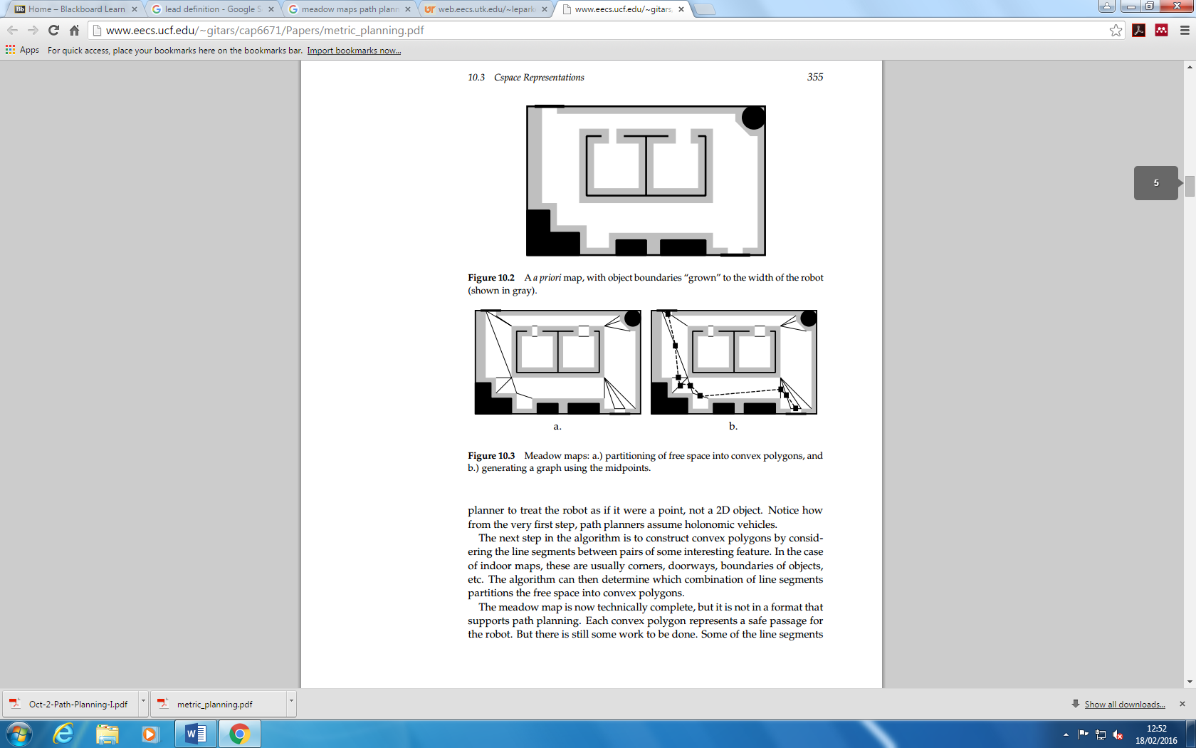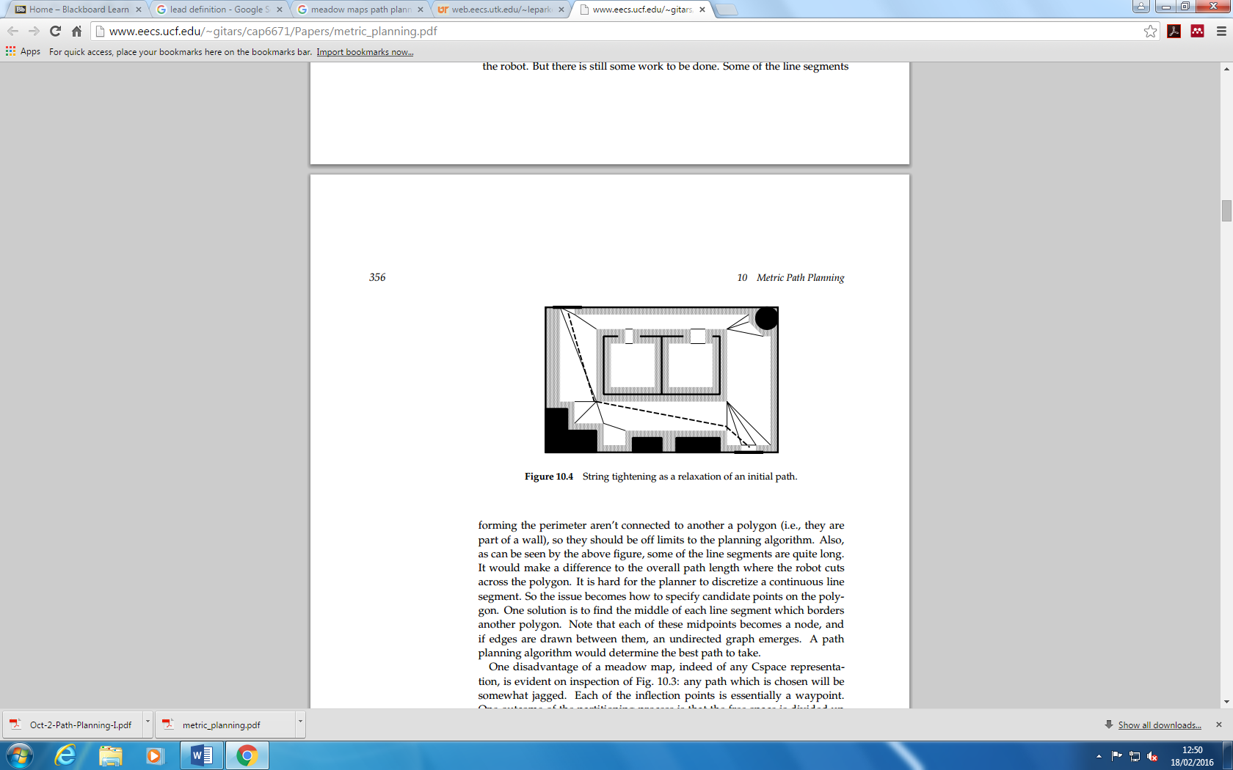

Figure 5 - Meadow Map Diagram (taken fromhttp://www.eecs.ucf.edu/~gitars/cap6671/Papers/metric_planning.pdf)

This method is more computationally light than the A* method, as it does not involve iterating over every possible placement of the robot between the goal and itself. But it still cannot be said that this method is computationally efficient; the process of creating the polygons can be quite expensive [32]. However again this behaviour does not have any in built redundancy for an incomplete map or a dynamic environment, such as the project brief requires, but again this functionality could be provided from the other behaviours working together. One additional problem with this algorithm is that the final route provided can be somewhat jagged, this is because the path makes sense geometrically but perhaps not in terms of a path provided to a robot [32]. This path therefore could be further optimised or “smoothed” so that it is more convenient for a robot to follow [32]. This would also take into account for the ability of a robot to turn gradually on an arc while moving; the solution provided by Meadow Maps only ever has the robot travel in a series of short straight lines. While this may provide the optimal solution in terms of ground covered, it is unlikely to be the shortest in terms of the amount of time taken for the robot to traverse this path. Overall the literature and the conclusions that have been drawn from it suggest that this method of path planning would not be suitable for this project; the level of computational complexity along with the risks involved with running this algorithm on an environment that may have unknown obstacles are too prohibitive for it to be considered any further.

# Concluded Design:

Having completed the review of the relevant literature surround the various problems this project presents, a proposed design has been reached. This proposed design consists of a Subsumption Architecture providing the following behaviours: Obstacle Avoidance *(using Potential Fields)*, Edge Following *(using PID)*, Random Wandering *(using the Potential Fields behaviour)*, and Mapping *(using the Modified Histogram Method)*. A Subsumption Architecture was selected due to its ability to react in real time to the robot’s environment [3], [5], [6] and due to the fact that this controller is already in built into the Aria Library. Potential Fields obstacle avoidance was selected because of its ability to incorporate “reactive” path planning and obstacle avoidance, and because of the ability to avoid local minima [8]–[11]. A PID controller was selected for the Edge Following behaviour in part because the project brief required the use of feedback control for at least one behaviour, and in part because PID provides a computationally light and robust solution to the problem of Line / Edge Following [14]–[18]. A mapping behaviour was selected over a path planning behaviour in part due to the increased level of computation involved, and also because the project brief states that the robot must be able to adapt to multiple maps and changing environments. These qualities are not the strongpoint of path planning algorithms, but have little or no impact on how well a mapping behaviour will function. The Modified Histogram method was selected for this behaviour because, judging from the literature it provides a very accurate solution for relatively low computational cost [28]. Additionally, due to the high degree of accuracy in Aria’s localisation model for the robot, the largest source of error in this algorithm is effectively removed entirely [28].

# Implementation/Approach to Problem:

## Software Architecture:

The Subsumption architecture used as a controller for this project because it ensured that each behaviour ran at the appropriate time. All behaviours were processed in parallel, and the priority system that Aria uses to configure which behaviours can subsume others allowed a fairly smooth transition between behaviours to be set up. Initially there were issues with this implementation; whereby the Edge Following and Obstacle Avoidance behaviours seemed to “fight” each other, resulting in neither behaviour becoming evident. However this was overcome by tailoring the priorities these behaviours and by ensuring that both behaviours only wrote to the “ArActionDesired” object, as opposed to the robot object itself. There was also a small issue in configuring the priorities of the different behaviours. This is due to the fact that the Aria library uses this configurable priority system, whereas typically Subsumption architectures utilise the Arbiter module to decide which behaviour should run. In order to fix and test this issue with the behaviour priorities, a number of different maps were designed to test the transitions between behaviours *(see appendix for screenshots of different maps)*.The resulting architecture performed very well to achieve all of its goals simultaneously *(see figure below for architecture diagram)*.

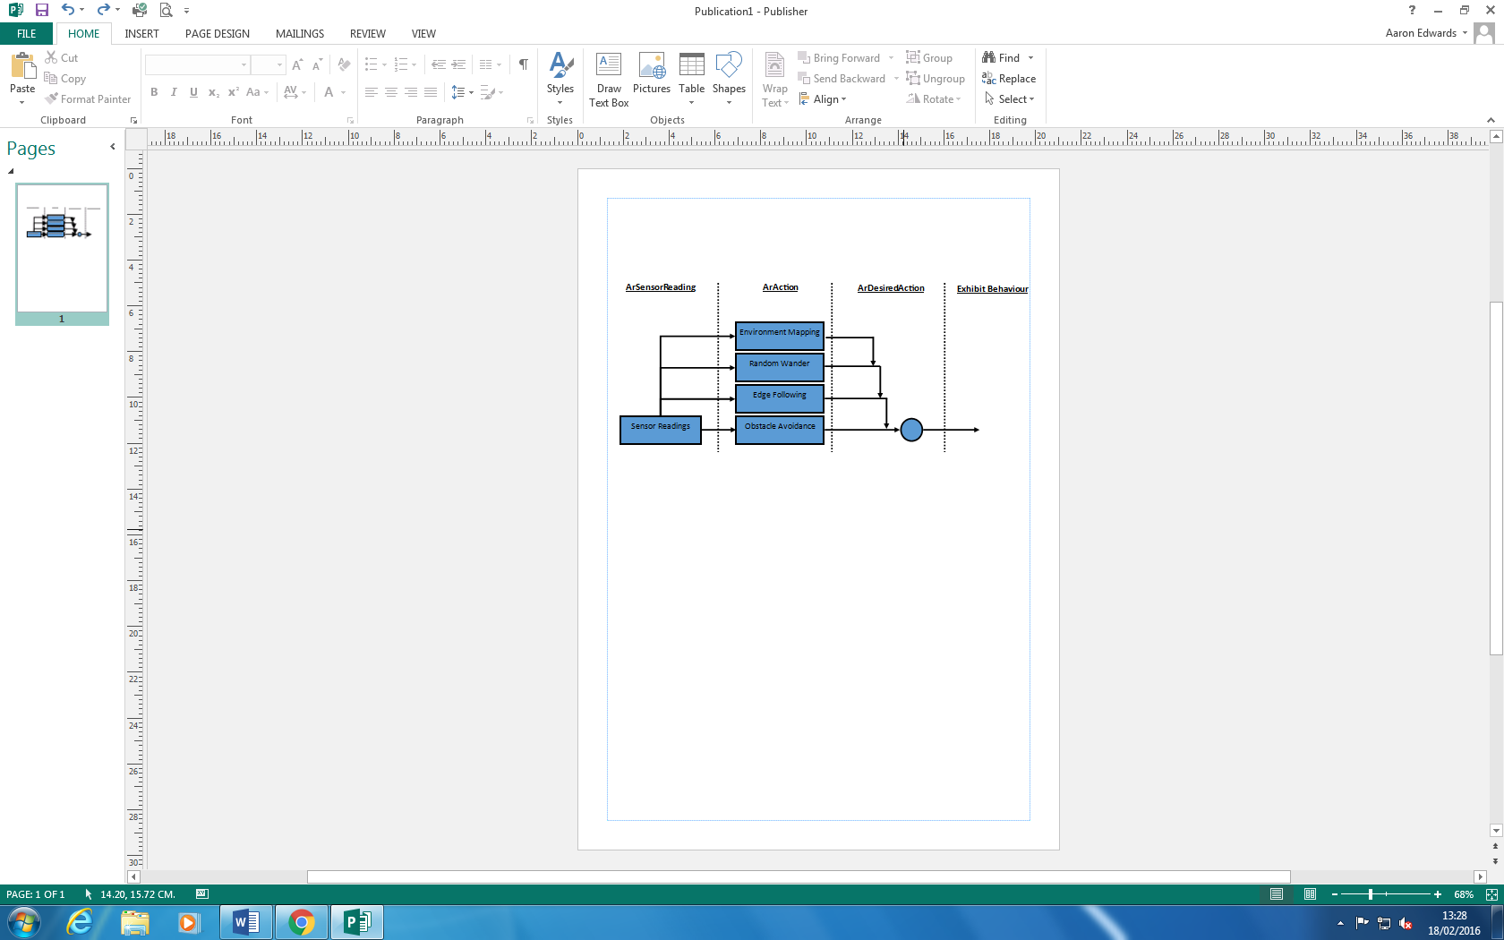

Figure 6 - Subsumption Architecture Diagram

## Obstacle Avoidance:

The obstacle avoidance behaviour was implemented using potential fields, and as such the control architecture for this behaviour does not use a Finite State Machine. This is because the Potential Fields algorithm should be run every cycle in order to maintain better control of the robot. In this way Obstacle Avoidance can almost be considered to be both a Passive and an Active behaviour. The first step to implement this was to create a data object to properly represent the force vectors the dictate where the robot moves. In order to do this I altered a class I had previously written to include a few extra functions that I would need for these calculations [33]. Once I had this data structure to represent two dimensional vectors, I created vectors around the robot based on the readings from the robot’s front facing sonar sensors *(sensors 1, 3, 4, 6)*. The first thing I did after populating these vectors was to output the vectors X component, Y component and angle, relative to the robot. This was done as a means of error checking. Once I had assured that the vectors were being populated correctly, I translated and rotated these vectors into global space. This was done to ensure that the robot would be “pushed” along the correct route. Next I implemented the obstacle avoidance section of this algorithm, to allow the robot to move along this route. This was done using the inverse square rule *(see equation 1-in Potential Fields section)*. The numerous vectors were combined to provide a resultant vector based on all of the obstacles the robot could detect. The robot would then calculate the heading to that waypoint and turn to face it. There were initially errors in this section of the algorithm, as the function atan2 returns the heading in radians as opposed to degrees. I was not aware of this until I decided to output the heading value while trying to debug why the robot was turning too little. Having solved this issue I also decided to make the speed of the robot relative to the closest object; I took the minimum value from the sonar sensors being used, and used this to calculate how far an obstacle is as a percentage of the maximum range of the sonar sensors. 5% of this is then taken and another 10 was then subtracted to ensure that if all else fails, the robot can still reverse away from an obstacle. This ensures that the robot can successfully turn away from all detected obstacles in time, while maintaining a good speed when no obstacles are detected. The next problem that was encountered was that when the robot was approaching an obstacle at 90° the robot would oscillate between trying to turn away in once direction, then the other. This problem was found to be an error in the Vector2D class I had changed to help me deal with the maths involved with creating the force vectors being applied to the robot; it was discovered that the cos() and sin() functions in C++ expect to be passed an angle in Radians. After changing my code to respect this, the robot was able to avoid obstacles no matter the angle of incidence *(see obstacle avoidance section of appendix)*.

Now that the robot was able to avoid obstacles I implemented that goal attraction element, to give the robot a kind of reactive / run time path planning. This was done using a similar equation to the obstacle avoidance section *(see equation 2)* and the Euclidean distance to the robot’s goal. Initially the level of gain (the linear scalar used to represent the field strength of the field in question) was far too high to give a good solution. This mean that, as the robot got closer to its goal, it would repeatedly try to navigate towards the goal in a “as the crow flies” fashion. This resulted in the robot getting stuck in one particular area *(see figure below)*.

Figure 4 – Potential Fields Path Planning First Attempt

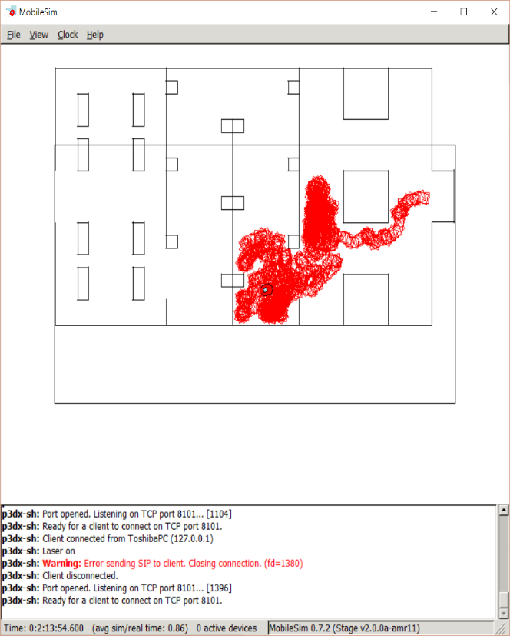

I had to make one small change to the map in so far that I had to ensure the doorway where to robot starts is closed off. This is because the robot kept navigating outside of the map and moving around the outside in order to reach its goal *(see figure below)*. In a way this shows that the potential fields algorithm is working well; as the robot chose “the path of least resistance” to arrive at its goal. However as this defeats the purpose of the whole assignment I decided to close off the map to force the robot to navigate through the map as intended.

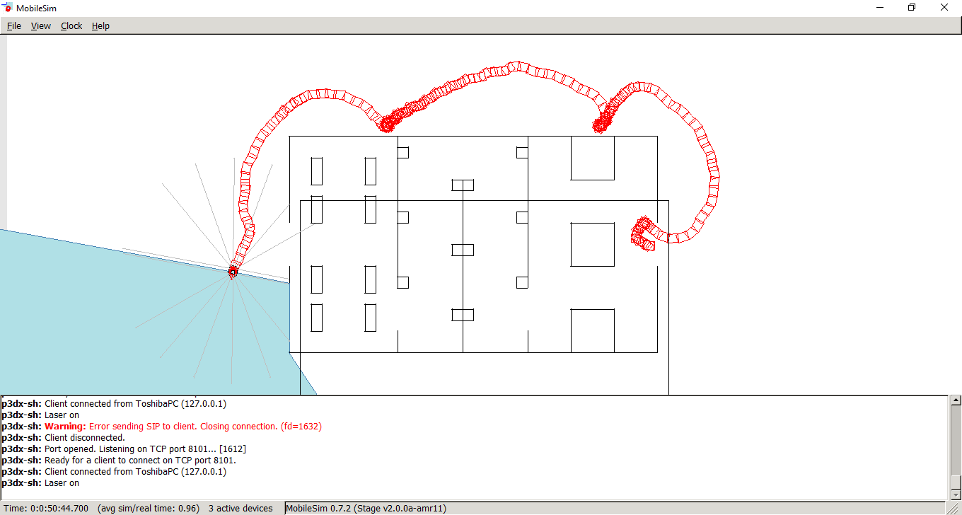

Figure 5 – Robot using Potential Fields to navigate to goal by circumventing map entirely.

After this I reduced the gain on the fields, this provided a better solution overall as it made the robot less susceptible to getting stuck in the same area. However it does make the robot more likely to collide with an obstacle if the obstacle is at an unusual angle. The robot also has trouble detecting the “doorways” in the map shown, as these are single lines with not much width to them *(see figure below).*

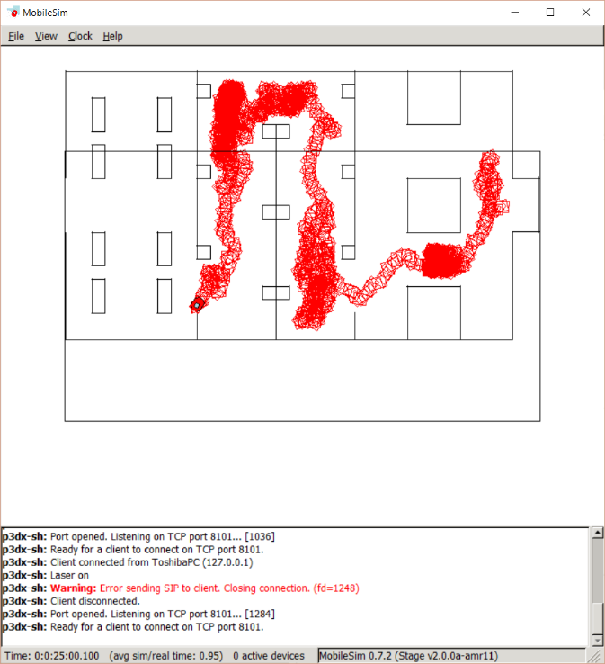

Figure 6 – Robot becoming stuck due to not being able to detect single thickness walls

## Edge Following:

The edge following behaviour was implemented using a PID feedback controller. This therefore needed quite a lot of tuning in order to provide a solution that was sufficiently smooth. The method for tuning the controller was similar to The manual method that is described in the literature [18]. However my approach differs where the Manual Method begins tuning the Integral component. This is due to the fact that this controller is only using Proportional and Derivative components; as Integral control is unnecessary since this coursework is using a simulator where there is no long term error such as flat tyres etc. The approach I took for implementing this behaviour was as follows: Firstly I devised a very simple finite state machine to help simplify the problem and make the code more readable *(see Edge Following section of appendix)*. Next I implemented the Proportional controller; this is done by taking a reading from the left and right sonar sensor on the robot and using this reading to calculate the error *(this value is the difference between the perceived distance to an obstacle and the defined set point)*. This error value was then multiplied by a pre-set gain value *(KP)*. KP was tailored by starting at 0 and then increasing it in small increments until the robot was visibly oscillating its position around the set point *(see Figure below)*. KP was started at 0 so that initially it could be seen with zero impact on the system.

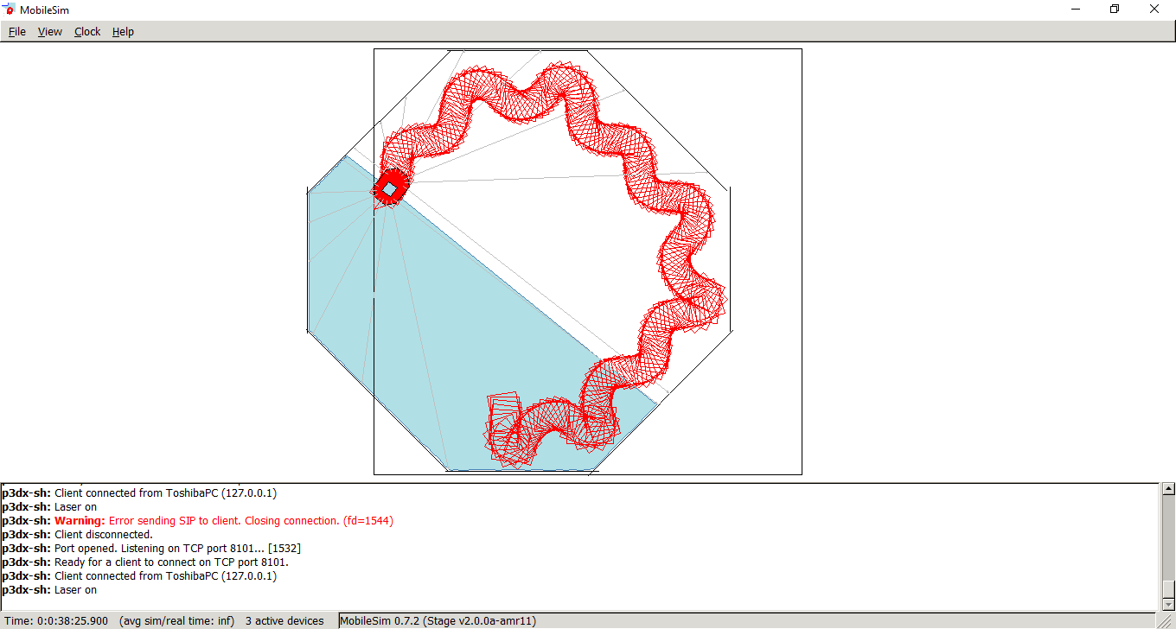

Figure 7 - Proportional Edge Following

The next step in the Manual Method is to tune the Integral component [18]. However as my controller does not use this component, I proceeded to implement the Derivative component. This is done by calculating the difference between the error *(distance of robot from set point)* on the current control cycle and the error on the previous cycle. This value is then scaled by another gain constant *(K­D)*. The constant KD was again started at 0 and then slowly increased until the oscillation that the Proportional controller creates is smoothed enough to give a good representation of the edge that is being followed. Once this is achieved the system should also be tested with regard to whether it adapts to corners / other obstacles adequately. If the robot does not turn sharply enough then KD should be decreased. One problem encountered during this stage of development was in finding a good compromise between reducing oscillation and keeping the adaptive quality of Proportional control. This was eventually found by testing the system on multiple different maps that feature different length of lines and sharpness of corners *(see figure below)*.

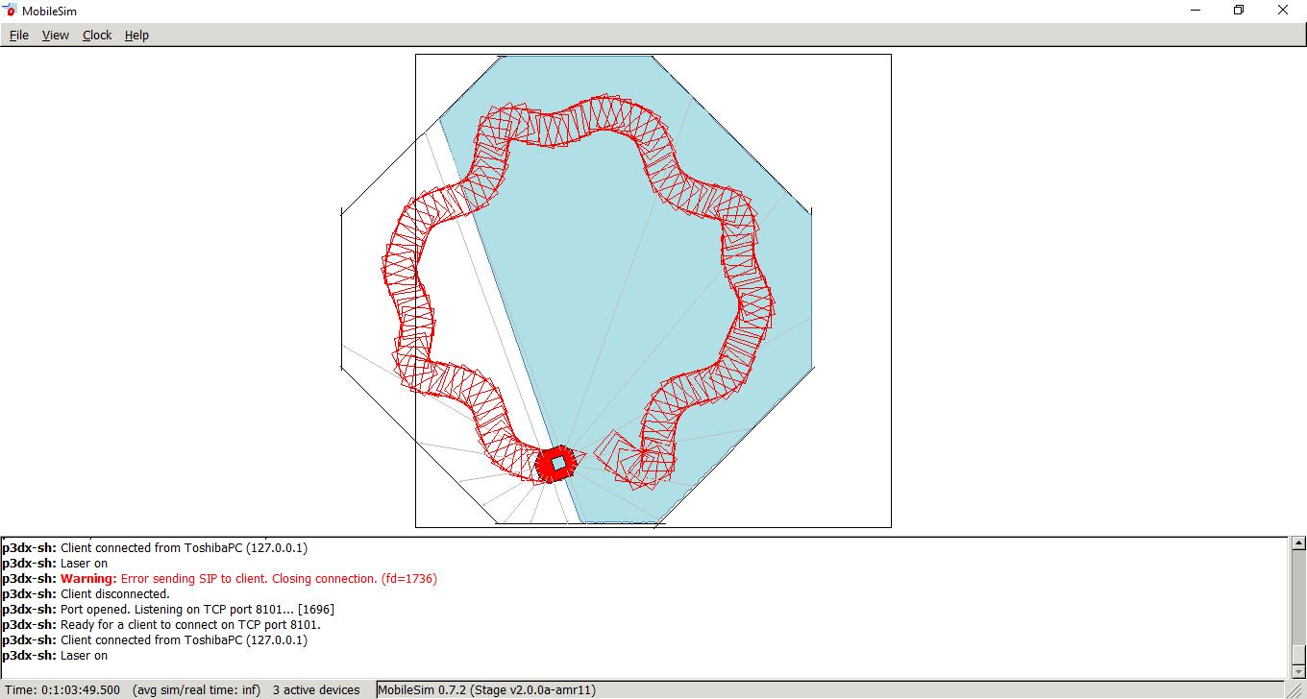

Figure 8 - Proportional and Derivative Edge Following

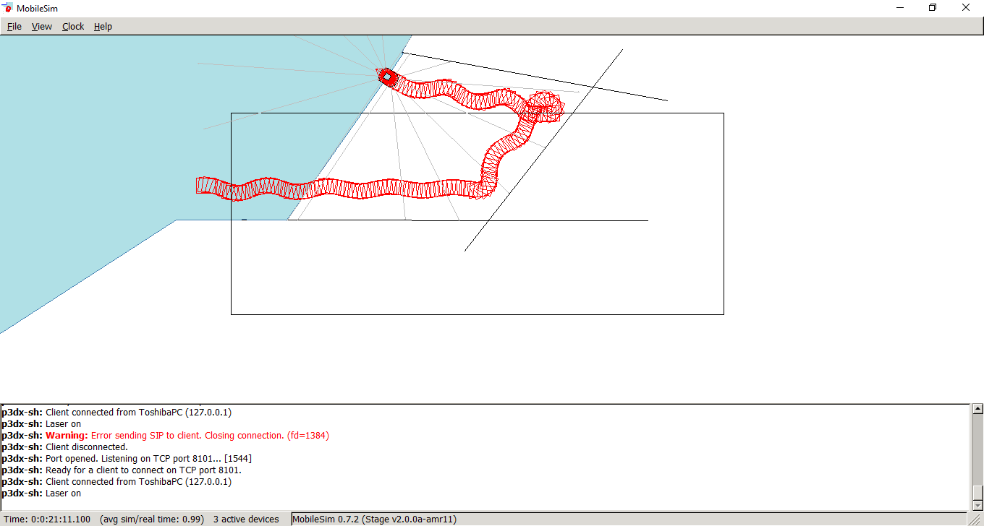

P = E * KP

D = (E - EP) * KD

O = P + D

Equation 5 - Proportional Control, Derivative Control and overall output.

Under this implementation the robot may only follow an edge until the robot “loses” contact with the edge, after which the random wander behaviour must take over. This was done to ensure that the maximum amount of the map is explored. The robot has a ten second “cool down” between periods of edge following. This was controlled through the use of a standard SFML timer; the robot may only follow an edge while it can still detect an edge, after which it experiences a ten second “cool down” time before it may follow an edge again.

One issue faced while implementing this behaviour was that after adding the other behaviours into the same controller, this controller needed retuning as the cycle speed of the system had changed, this was done following the same steps as the first time it was tuned. In addition to following the same steps to tune the PID, a level of quantitative analysis was used to help improve the edge following *(see Edge Following section of Testing)*.

## Wandering/Exploration:

The method by which the robot “randomly” wanders is by resetting the location for the Potential Fields’ Goal, this is done by using the in-built C++ function Rand(), which returns a random number. This was set between two boundaries *(the limits of the map)* by using the modulus operator and then applied to reset the Goal’s position. An SFML timer is used to ensure that this goal is only reset once every 10 seconds. In order to reset the location of the goal, this behaviour had to have access to both the Obstacle Avoidance behaviour in order to reset the location of the Goal, and the Edge Following behaviour in order to decide whether or not this behaviour should subsume control and cause the robot to randomly wander instead of line follow. The wander behaviour has access to the other behaviours via pointer. Strictly speaking this implementation does not fit with the normal structure of a Subsumption architecture; normally each behaviour can only communicate with the others by use of a global “state” object, such as the ArDesiredState class that is used to control the robot in Aria. However as Aria does not include any functionality to meet my requirement, I had to create a work around. Other than the lack of a data object to communicate with, no other issues were faced during the implementation of this behaviour. Again this behaviour uses a finite state machine to help simplify the transitions between states *(see Wandering section of appendix)*. Use of a FSM wasn’t strictly necessary for such a simple behaviour, however I decided to use one as it makes the code more readable and follows better programming practices.

## Mapping:

As this behaviour can be seen as a passive behaviour, in as far as no action is taken on the environment through the robot’s actuators, this behaviour does not use a Finite State Machine. This is because there is no “idle” state for this behaviour; i.e. there are no circumstances in which this behaviour should not run. For the purposes of this implementation, I changed several small aspects of the Modified Histogram Technique; firstly I wanted to make this behaviour more dynamic so that it would work with any map or environment without having to pre-configure the map size. In order to do this, I replaced the pre-loaded map that is used in the literature [29] with dynamically adding mapObject elements onto a vector. Each time an object is loaded into this data structure, it has an opacity of 5, as advised by the literature [29]. As I am displaying the occupancy graphically I decided to display all detected points and simply alter the display such that mapObjects with a higher opacity are shown with a larger radius and a brighter shade *(see mapping section of appendix)*. Using this method, it is easy for the user to distinguish between areas of the map that represent an area that has a greater degree of certainty of occupancy.

Each time an object is detected, any other object that is within a set range has its opacity value increased, as it is more likely to be a valid reading from the robot. The algorithm also searches for any mapObject that is more than half a meter away from any others, any that are found have their opacity reduced. This helps to further reduce any outliers that may be present. This approach deviates again from the method in the literature, whereby there is no mention of increasing the opacity of any immediately surrounding objects, instead the literature suggests randomly decreasing the opacity of mapObjects inside the search space [29]. However I found that relying on this method alone was less systematic, and would often reduce the opacity of objects that I was fairly certain were valid. The idea behind the literature suggesting this is that if these nodes were valid, eventually the robot would re-cover the same area and rediscover them. However due to the shape of the map to be used for this assignment, this approach is less convenient as it takes the robot a long time to navigate to all areas of the map. While the mapping algorithm does periodically reduce the opacity of a random node in the map, it does not do so as often as the literature implies it should.

During the implementation of this behaviour, I encountered a lot of problems that were borne of the computational complexity that is caused by iterating through the vector and comparing its contents against each other; this caused the behaviour to run behind its allotted time, which in turn started to have a negative effect on the other behaviours. In an effort to reduce this impact I tried several things to try and make the programme more efficient; I outsourced the drawing of the map and robot to a separate thread, I slimmed down all data structures in the mapper behaviour and the mapObject class as far as was convenient. Finally I experimented with reducing how often the “improvement” algorithm ran on the scattergram map, so that it ran once every 30 seconds. This greatly improved the computational efficiency of the program, thus improving the effectiveness of all the behaviours that were being adversely impacted. However reducing the amount that the scattergram is improved allows more erroneous sonar readings to build up and hence be considered valid readings. This has led to a higher rate of error in the finished result *(see mapping section of appendix)*.

Another problem that was encountered during the implementation of this behaviour is that the iterator that was used in the drawing function would become invalidated, causing the system to crash at run. After investigating this problem further and discussing the problem with some lecturers *(P.Hardaker, S.Coupland)*, it was found that using the “push_back” function to add elements to a vector can sometimes cause the vector’s iterator to become invalidated [34]. The fix for this problem was never found, despite multiple online forums discussing the topic. Ultimately a simple for loop was used, accessing each element in the loop with the random access operator. This is not normal programming practice as this is less robust. However as using Iterators caused the programme to crash I was left with no alternative.

Additionally, there was a small bug in the rotation/translation matrix I was using, which caused the map to never take note of any horizontal lines. This bug was caused by having:

$$\begin{matrix}xCosθ-ysinθ \\ ySinθ+xCosθ\end{matrix}$$

Whereas, the equation should be:

$$\begin{matrix}xCosθ-ysinθ \\ xSinθ+yCosθ\end{matrix}$$

Fixing this matrix resolved the issue, allowing the map to consist of lines in both x and y.

I would very much have liked to add RANSAC on top of the result of the Modified Histogram Technique, to further improve the accuracy and clarity of the map provided. However, this was not possible due to the already computationally heavy nature of this behaviour. Already I was having to make concessions on the accuracy of the map in order to improve the cycle rate of the programme.

# Performance Review:

The performance of the system as a whole is very good; I had expected far more emergent behaviours to arise from combining the different layers of the Subsumption architecture. Each behaviour activates when I would expect it to, and relinquishes control when I would expect. For example the project brief specifies that the robot should only line follow for a maximum of ten seconds, after which the wander behaviour should take control and have the robot move away. This transition is very smooth and seems to be very robust.

The obstacle avoidance works well to avoid collisions and help direct the robot in the general direction of the goal. This is not as effective as it could be due to the shape of the map provided; I had to decrease the strength of the attraction vector because the robot would get stuck in one of a few areas. This would be caused by the attraction vector pulling the robot into an area, such as the two corridors, the robot would then be pushed along the corridor by the obstacle fields. Coincidentally this direction would conflict with the goal vector. This causes the robot to move up and down the same corridor repeatedly, or get stuck in one corner. This is not the case with all maps; in fact after testing it became apparent that the field strength variable must be tuned by quite a large margin, depending on the layout of the map the robot is in. For example, it was found that the optimum field strength while using the provided map was roughly one hundredth the size of the optimal field strength for the “avoidTest.map” that I created. This could mean that there is a flaw in this implementation, which could be re-addressed should this approach be taken again.

The Edge Following behaviour was very accurate and smooth indeed, when run independently of the others. However once this behaviour was in parallel with the others, the amount of oscillation that is evident was much greater. I suspect this is due to the change in the cycle speed of the Aria programme, caused by running multiple, more computationally heavy behaviours like the Mapping, in parallel. I attempted to re-tune the PID after compiling these behaviours together, which improved the results somewhat, however the resulting system was still far inferior to the initial one that had been created.

The Random Wander behaviour worked very well; the decision to give this behaviour pointer access to both the obstacle avoidance and edge following behaviours goes against the Subsumption design paradigm, however this decision allows the Wander behaviour to only subsume control from edge follow at the correct time, and use the potential fields algorithm to achieve the wandering behaviour. This makes this behaviour lighter and more efficient.

The Mapping behaviour works fairly well, I would very much have liked to put RANSAC or some other line of best fit algorithm on top of the Modified Histogram Method, and to have had the map improvement algorithm run more often in order to provide an even better result. However the level of iterations required for this proved too much for Aria to deal with and keep timing correctly. In a Soft Real Time System, this would not matter as much, as some task deadlines could be missed without causing too much of an issue. However when this was tested, the other behaviours began to suffer from the lower cycle rate of the programme. If I were to attempt this problem again I would look into other ways of optimising this behaviour so that the resultant map might be of better quality. Another solution to this might be to have the robot move at a much lower speed, or to use the Laser range finders, however I decided that for this project the robot performed better overall at a higher speed and could not justify re-implementing this behaviour to use the lasers at the detriment of other tasks, such as testing.

# Testing:

The Edge Following and Obstacle Avoidance behaviours are the only ones that are particularly applicable for quantitative analysis on their performance. Therefore this testing will be more empirical and less dependent on my perception of what a good result should “look like”. The Mapping and Wandering behaviours were only tested by means of utilising multiple different test environments and my own subjective observations on their respective performances *(see Test Maps section of appendix)*. Obstacle avoidance can be assessed based on how close the robot came to obstacles *(see obstacle avoidance section of appendix)*. As a means of analysis, this is not the best measure of this behaviour, so observational analysis will also be performed *(see Test Maps section of appendix).* Edge Following however, was subject to a good level of quantitative analysis using Microsoft Excel.

## Edge Following:

This graph shows the measured Error in the system *(distance of the robot from the desired set point)* per time-step. Some mild oscillation can be seen on both the graph and the screenshot in the lower right section of the figure below. Some level of oscillation will always be present in a feedback control system, however it may be minimalised. The PD controller used in this project finds a good balance between reducing the error, keeping the robot’s velocity as high as possible and ensuring the robot can still turn sharply enough to avoid colliding with walls *(see figure below)*. After further experimenting with this map, which contains a corner over 90°, having a PD controller that provides a more smooth, less noisy solution reduces the robot’s ability to make tight corners adequately.

This shows that the implemented PD controller is very successful. All error data can be seen in table 1 *(see Edge Following Section of Appendix)*.

P: 0.175 D: 0.95

Average Error: -10.5

Standard Deviation: 105

Range: 755

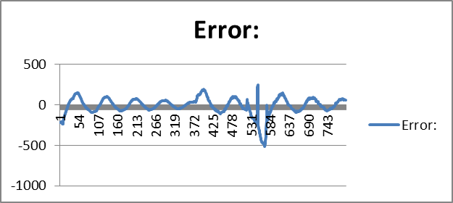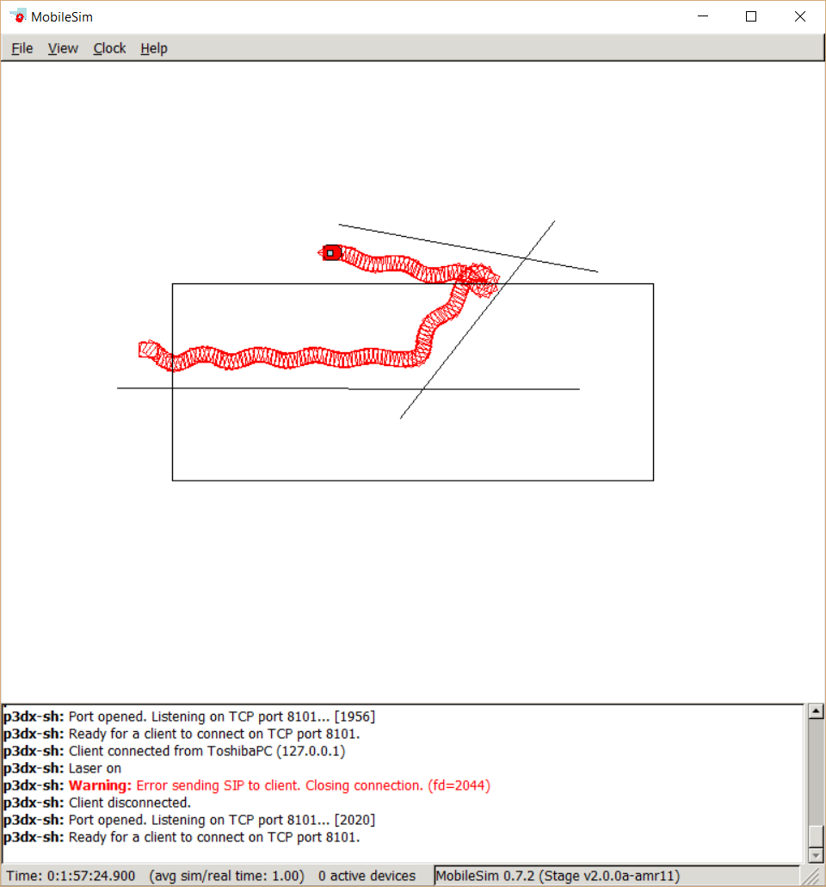

Figure 7 - Analysis of Edge Follow Behaviour

Corner 2

Corner 1

# Conclusion:

In conclusion, a Subsumption Architecture has been implemented as a controller for a mobile robot. The Aria simulator library was used to do this. Various behaviours were created in this architecture, such as Obstacle Avoidance, Edge Following, Environment Mapping and Wandering. These behaviours utilised were successful to various degrees; the obstacle avoidance behaviour used Potential Fields to avoid collisions and included a level of reactive path planning. This behaviour can be judged a success, as it enables the robot to navigate its environment with little or no difficulty. The Edge Following behaviour made use of a PD feedback control system to maintain a set distance from any detected edges. This behaviour was fairly successful also; its effectiveness suffered somewhat after being combined with the other behaviours, causing an increased level of oscillation in its level of error. It is suspected this was caused by the change of the programme’s cycle speed, as some level of oscillation has remained despite efforts to retune the PD controller. The Wandering behaviour made use of the Potential Fields system to dynamically re-locate the robot’s goal location, thus causing the robot to move in a less predictable pattern. This behaviour can be judged a success due to its reliability and simplicity. The Mapping behaviour is by far the least successful; the level of computational involved in the Modified Histogram Technique proved to be too large for the Aria platform. This meant that concessions had to be made in terms of the accuracy of the map. Additionally the section of the Mapping behaviour that display the map using SFML could be improved greatly. If this project were to be attempted again, another method for mapping would be implemented- likely another method that uses occupancy grids, but one that is more computationally efficient. If more time were available to complete this project I would also attempt to improve the graphical output of the map, especially in terms of the accuracy of the plotted points.

# Bibliography:

[1] “Aria: ARIA Developer’s Reference Manual.” [Online]. Available: http://robots.mobilerobots.com/Aria/docs/main.html. [Accessed: 12-Nov-2015].

[2] “MobileRobots ARIA Robotics SDK.” [Online]. Available: http://www.mobilerobots.com/Software/ARIA.aspx. [Accessed: 01-Feb-2016].

[3] P. Fitzpatrick, “Behaviour-Based Control in Mobile Robotics.”

[4] “finite state machine.” [Online]. Available: https://xlinux.nist.gov/dads//HTML/finiteStateMachine.html. [Accessed: 09-Feb-2016].

[5] J. E. Arnold, “Experiences with the subsumption architecture,” in *[1989] Proceedings. The Fifth Conference on Artificial Intelligence Applications*, 1989, pp. 93–100.

[6] R. Pfeifer and C. Scheier, “Understanding Intelligence.” MIT Press, pp. 199–225, 2001.

[7] A. Ayesh, “Architectures,” 2014. [Online]. Available: https://vle.dmu.ac.uk/bbcswebdav/pid-2920718-dt-content-rid-4256864_1/courses/IMAT2405_2014_Y/L19-L20-Architectures.pdf.

[8] I. Susnea, V. Minzu, and G. Vasiliu, “Simple, real-time obstacle avoidance algorithm for mobile robots,” *Recent Adv. Comput. Intell. Man-Machine Syst. Cybern.*, no. figure 2, pp. 24–29, 2009.

[9] “Potential Fields Tutorial.” [Online]. Available: http://phoenix.goucher.edu/~jillz/cs325_robotics/goodrich_potential_fields.pdf. [Accessed: 05-Nov-2015].

[10] J. Borenstein and Y. Koren, “Real-time obstacle avoidance for fast mobile robots,” *IEEE Trans. Syst. Man. Cybern.*, vol. 19, no. 5, pp. 1179–1187, Sep. 1989.

[11] “Local Path Planning Using Potential Field.” [Online]. Available: http://www.cs.mcgill.ca/~hsafad/robotics/. [Accessed: 10-Nov-2015].

[12] A. Thomas Abraham, S. S. Ge, and P. Y. Tao, “A topological approach of path planning for autonomous robot navigation in dynamic environments,” in *2009 IEEE/RSJ International Conference on Intelligent Robots and Systems*, 2009, pp. 4907–4912.

[13] Q. Yang and W. Yan, “Intelligent path planning for automated guided vehicles system based on topological map,” in *2012 IEEE Conference on Control, Systems & Industrial Informatics*, 2012, pp. 69–74.

[14] “Feedback Control Lecture.” [Online]. Available: https://web.stanford.edu/~boyd/ee102/ctrl-static.pdf. [Accessed: 09-Feb-2016].

[15] J. Doyle, B. Francis, and A. Tannenbaum, “Feedback Control Theory.” [Online]. Available: http://www.control.utoronto.ca/people/profs/francis/dft.pdf. [Accessed: 09-Feb-2016].

[16] “Control Tutorials for MATLAB and Simulink - Introduction: PID Controller Design.” [Online]. Available: http://ctms.engin.umich.edu/CTMS/index.php?example=Introduction&section=ControlPID. [Accessed: 09-Feb-2016].

[17] “PID without a PHD.” [Online]. Available: http://cms.edn.com/contenteetimes/documents/embedded.com/2000/f-wescot.pdf. [Accessed: 09-Feb-2016].

[18] S. Temel, S. Yağli, and S. Gören, “Electrical and Electronics Ee402- Discrete Time Control Systems Recitation 4 Report P , Pd , Pi , Pid Controllers,” *https://www.google.com.pr/url?sa=t&rct=j&q=&esrc=s&source=web&cd=1&cad=rja&uact=8&ved=0CB0QFjAAahUKEwig6ZPnyInJAhUG5CYKHX6oBDI&url=http%3A%2F%2Fwww.researchgate.net%2Ffile.PostFileLoader.html%3Fid%3D54685991d11b8bc9668b461a%26assetKey%3DAS%253A27363520017*, p. 63, 2012.

[19] L. P. Perera, J. P. Carvalho, and C. Guedes Soares, “Solutions to the Failures and Limitations of Mamdani Fuzzy Inference in Ship Navigation.,” *IEEE Trans. Veh. Technol.*, vol. 63, no. 4, pp. 1539–1554, 2014.

[20] “10 - Sugeno-TSK model.” [Online]. Available: http://www.csee.wvu.edu/classes/cpe521/old/10 - Sugeno-TSK model.ppt.

[21] P. Kumar and K. Sridharan, “Field Programmable Gate Array-based Robotic Exploration of an Indoor Environment,” in *2006 1ST IEEE Conference on Industrial Electronics and Applications*, 2006, pp. 1–3.

[22] A. Renzaglia and A. Martinelli, “Potential field based approach for coordinate exploration with a multi-robot team,” in *2010 IEEE Safety Security and Rescue Robotics*, 2010, pp. 1–6.

[23] V. A. M. Jorge, R. Maffei, G. S. Franco, J. Daltrozo, M. Giambastiani, M. Kolberg, and E. Prestes, “Ouroboros: Using potential field in unexplored regions to close loops,” in *2015 IEEE International Conference on Robotics and Automation (ICRA)*, 2015, pp. 2125–2131.

[24] “An Introduction to Mapping and Localization - Tutorials.” [Online]. Available: http://forums.trossenrobotics.com/tutorials/introduction-129/an-introduction-to-mapping-and-localization-3274/. [Accessed: 01-Feb-2016].

[25] “Approaches to Mobile Robot Localization in Indoor Environments.” [Online]. Available: https://www.diva-portal.org/smash/get/diva2:8964/FULLTEXT01.pdf. [Accessed: 01-Feb-2016].

[26] A. Jha and M. Kumar, “Two wheels differential type odometry for mobile robots,” *Proceedings of 3rd International Conference on Reliability, Infocom Technologies and Optimization*, Oct-2014. [Online]. Available: http://ieeexplore.ieee.org/xpl/articleDetails.jsp?arnumber=7014709. [Accessed: 12-Nov-2015].

[27] “A Primer on Odometry and Motor Control.” [Online]. Available: http://ocw.mit.edu/courses/electrical-engineering-and-computer-science/6-186-mobile-autonomous-systems-laboratory-january-iap-2005/study-materials/odomtutorial.pdf. [Accessed: 01-Feb-2016].

[28] D. Osmankovic and J. Velagic, “Modified histogramic technique for mobile robot indoor environment mapping based on uniform random distribution,” in *2012 12th IEEE International Workshop on Advanced Motion Control (AMC)*, 2012, pp. 1–6.

[29] J. Borenstein and Y. Koren, “Histogramic in-motion mapping for mobile robot obstacle avoidance,” *IEEE Trans. Robot. Autom.*, vol. 7, no. 4, pp. 535–539, 1991.

[30] K. G. Derpanis, “Overview of the RANSAC Algorithm,” *Image Rochester NY*, vol. 4, no. 1, pp. 2–3, 2010.

[31] D. Ferguson, M. Likhachev, and A. Stentz, “A guide to heuristic-based path planning,” *Proc. Int. Work. Plan. under Uncertain. Auton. Syst. Int. Conf. Autom. Plan. Sched.*, pp. 1 – 10, 2005.

[32] M. P. Planning, “Metric Path Planning.”

[33] A. Edwards, “Vector2D Class.” Leicester, 2013.

[34] “Does .push_back invalidate existing vector iterators? - C / C++.” [Online]. Available: https://bytes.com/topic/c/answers/584854-does-push_back-invalidate-existing-vector-iterators. [Accessed: 23-Feb-2016].

# Appendices:

## Control Architectures:

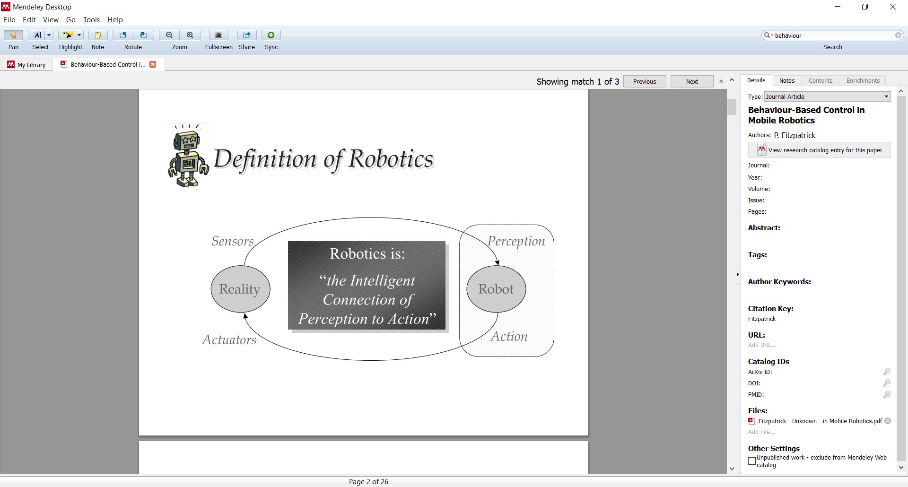

1- Taken from P. Fitzpatrick, “Behaviour-Based Control in Mobile Robotics.

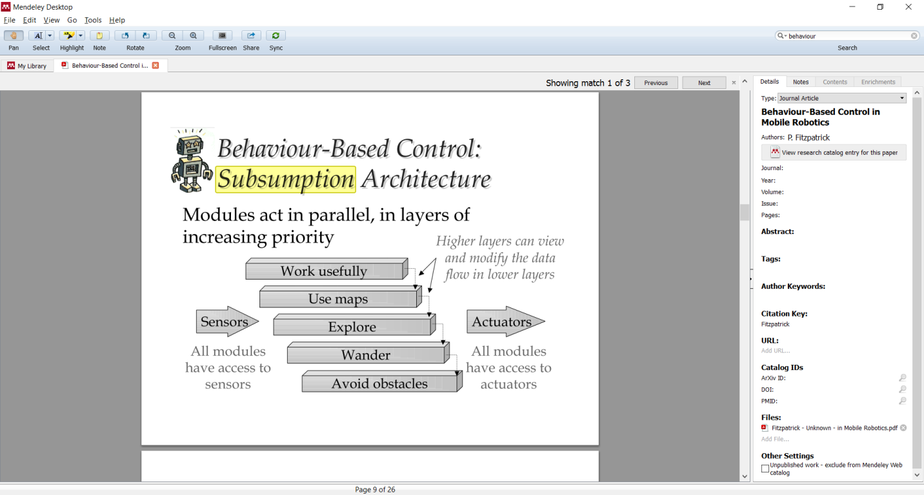

2 – Taken from P. Fitzpatrick, “Behaviour-Based Control in Mobile Robotics.

## Test Maps:

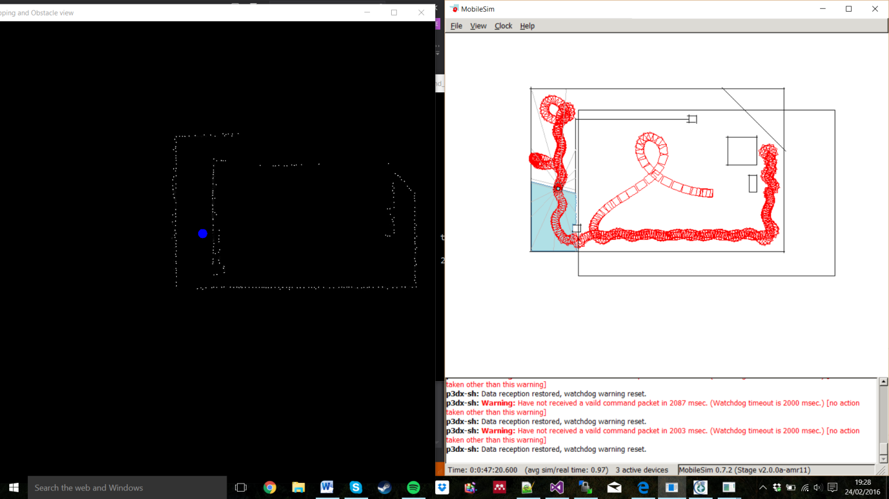

Figure 8- Obstacle Avoidance Test map

Gap too narrow for robot to fit through.

Example of Edge Following

Wandering behaviour causes change of direction

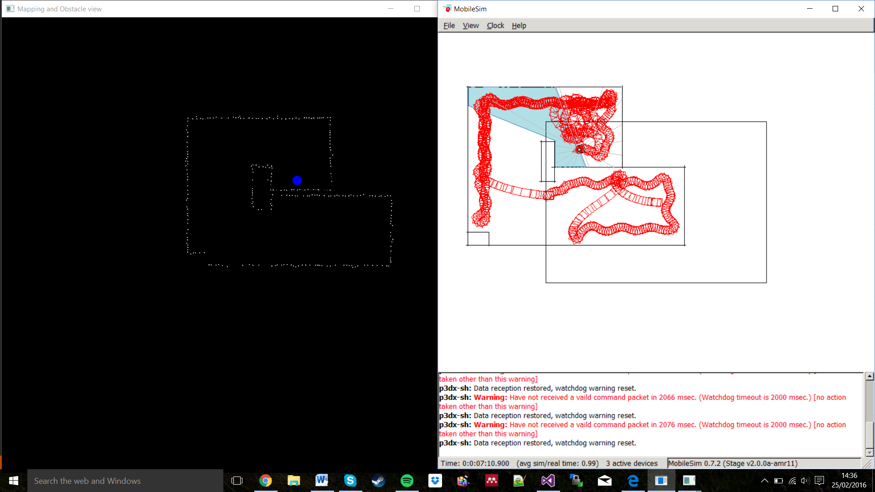

Figure 9- Mapping Test Map

Edge Following

Robot detected same line as two separate lines, error from odometer likely the cause, kinematic model could be improved.

Wandering Behaviour Struggling against Edge Following, some improvements on priorities might be necessary.

## 

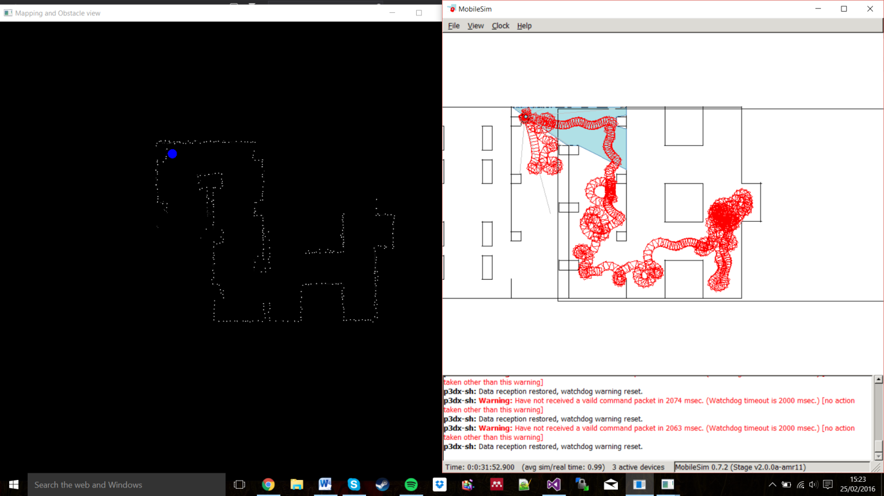

Figure 10- Final Test

Robot spins a lot on this map, likely due to field strength being too high for this map.

Edge Following performs well to help robot navigate difficult corner

Map is visibly very accurate, small amount of noise in highlighted areas.

## Obstacle Avoidance:

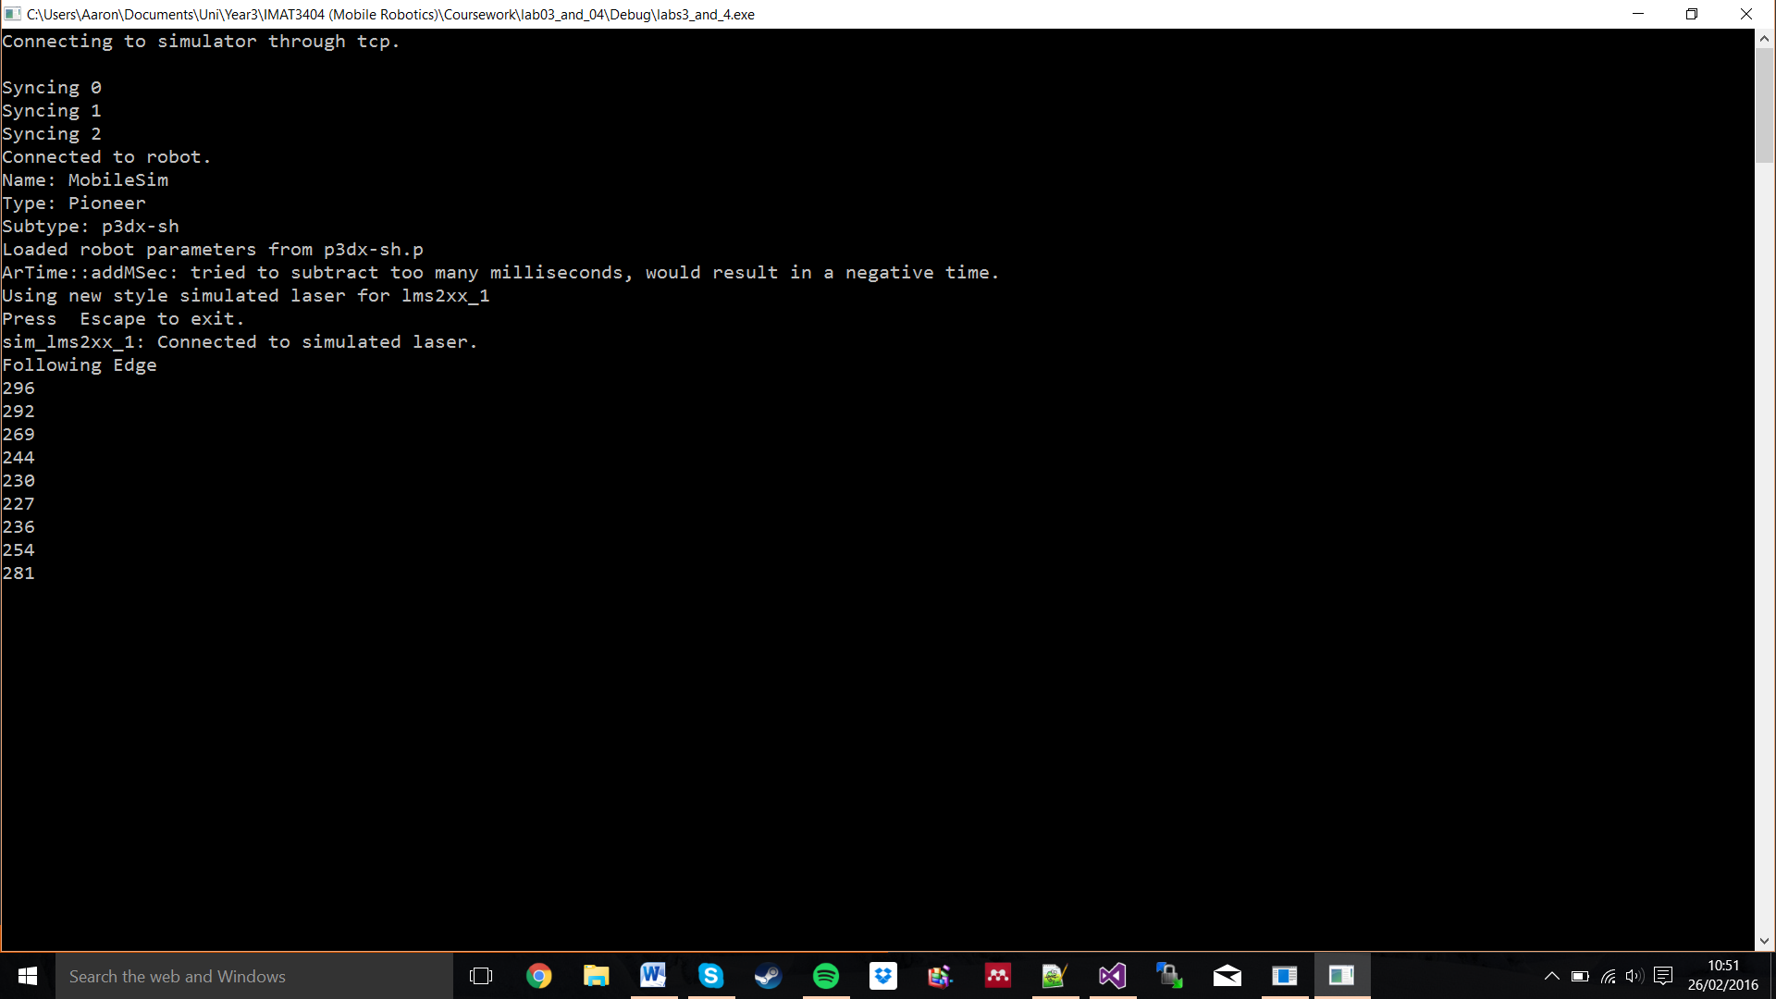

Figure 11- Robot's distance from obstacles

If the robot detected an obstacle closer than 300mm, it outputted the distance to the console. The robot only came closer than 300mm once, when it approached a section of the map that strictly speaking was too narrow for it to pass through safely. The robot came within the 250mm boundary defined by the brief in turning away from that narrow section of the map.

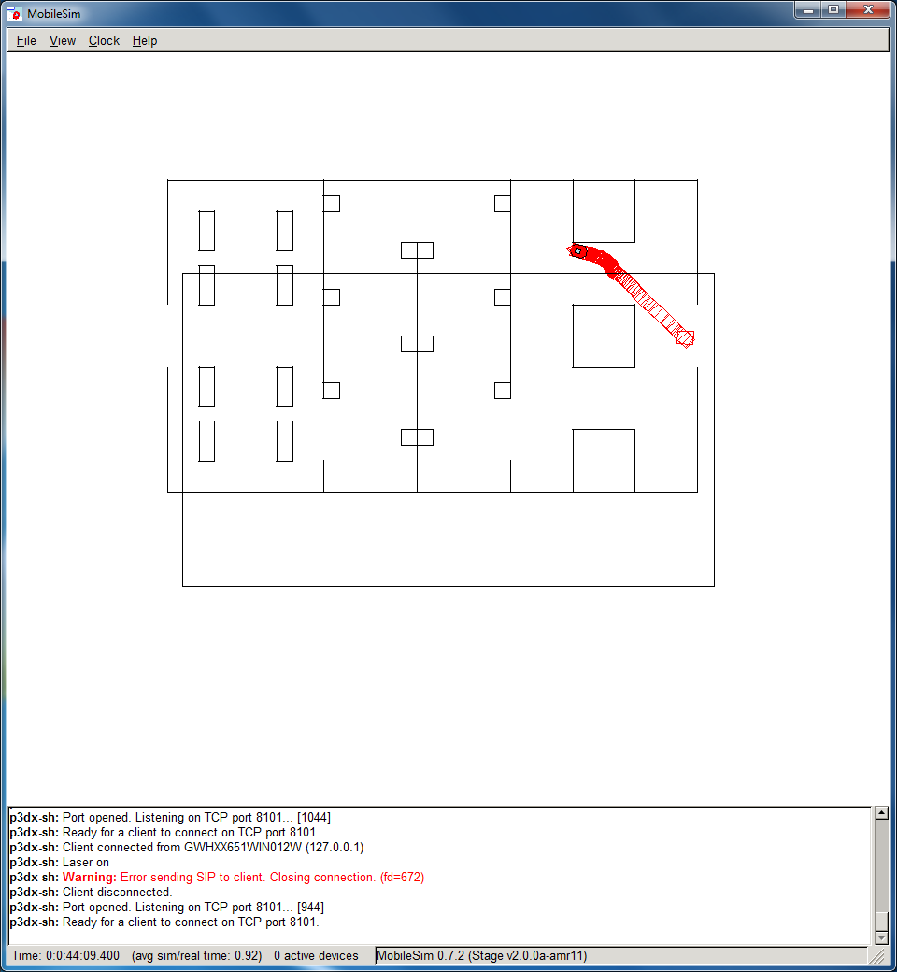

Figure 13- Evidence of Obstacle Field not providing enough force on the robot

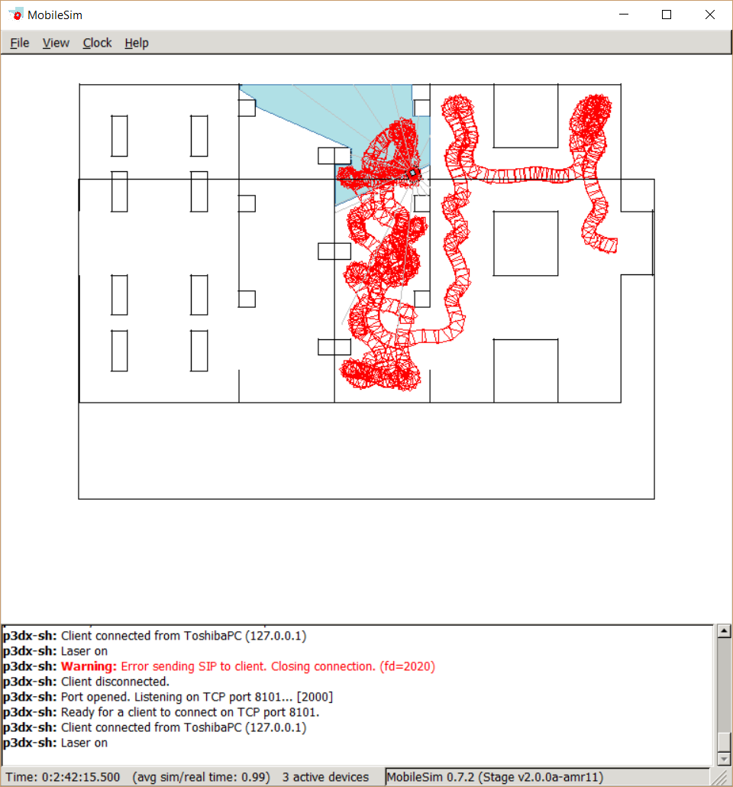

Figure 13- Example of final resulting obstacle avoidance behaviour

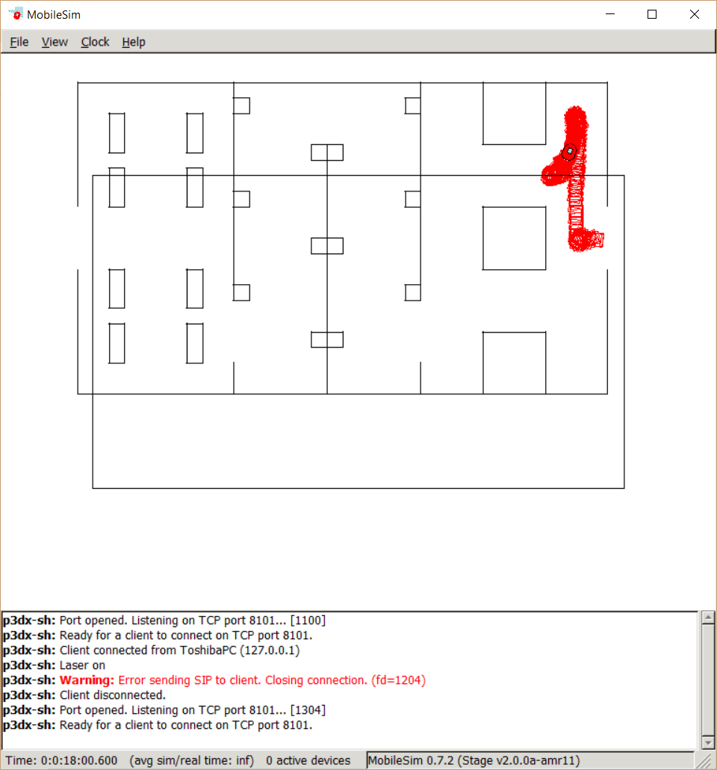

Figure 15- Potential Fields avoiding local minima

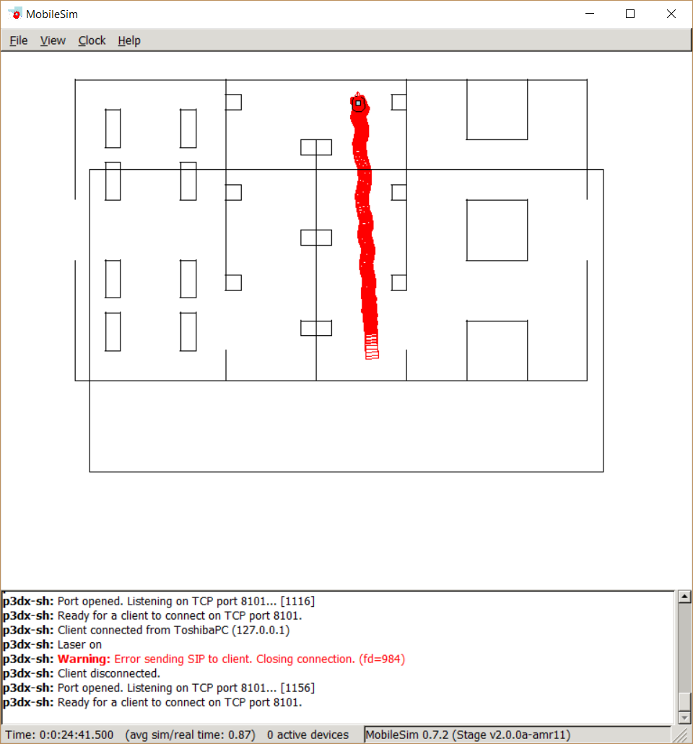

Figure 15- Potential Fields performing in an Edge Following like manner

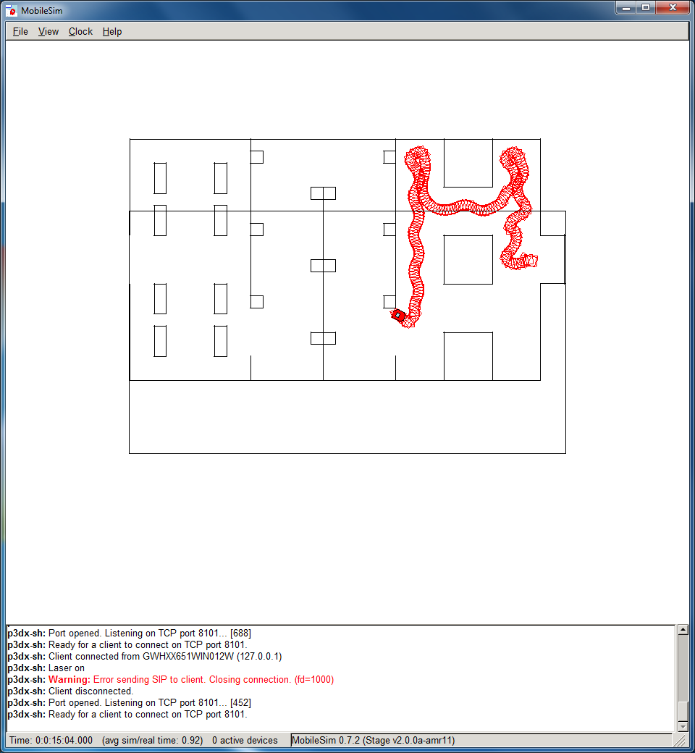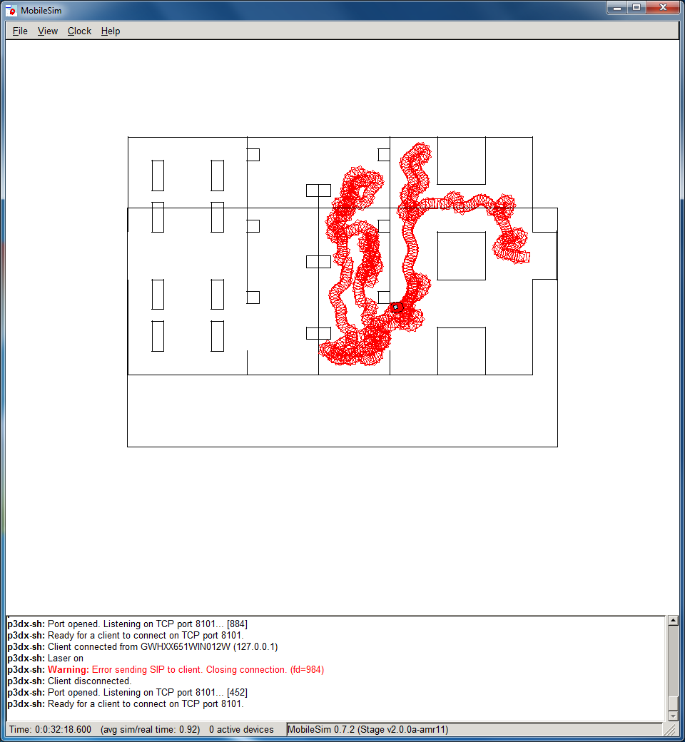

Figure 16- Evidence of Robot having difficulty detecting single thickness lines

## Edge Following:

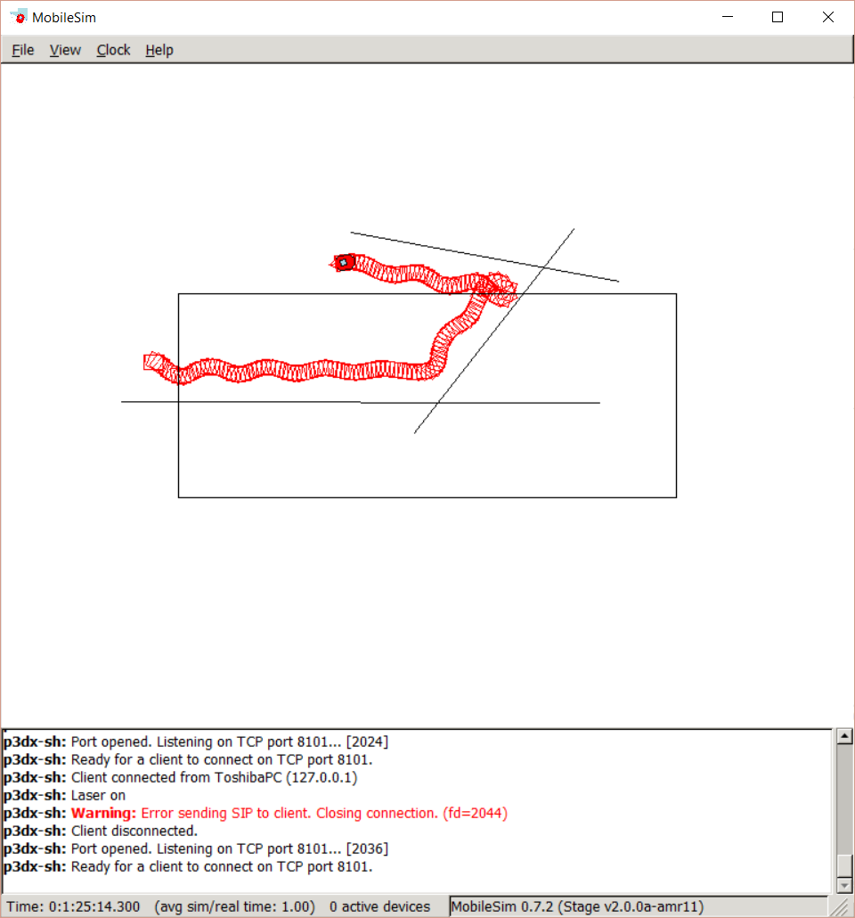

Figure 17- Example of Edge Following

Timer Expired OR Edge Lost

Timer Expired AND Edge Detected in Range

Figure 18- Finite State Machine Diagram for Edge Following Behaviour

|  |  |  |  |  |  |  |  |  |  |  |  |  |  |  |  |  |  |
| --- | --- | --- | --- | --- | --- | --- | --- | --- | --- | --- | --- | --- | --- | --- | --- | --- | --- |
| **TimeStep:** | 0 | | 1 | 2 | | 3 | 4 | 5 | 6 | 7 | 8 | 9 | 10 | 11 | 12 | 13 | 14 |
| **Error:** | -216 | | -216 | -214 | | -214 | -214 | -217 | -223 | -233 | -238 | -203 | -176 | -156 | -140 | -127 | -113 |
| **Average (of all data):** | | -10.462217 | | |
| **STD DEV (of all data):** | | 105.125286 | | |
| **Range (of all data):** | | 755 | | |

Table 1- First 15 Time Step's Error Readings from Edge Following Behaviour

## Wandering:

Goal waypoint reset

Timer Expired

Timer not expired

Figure 19- Finite State Machine Diagram for Wandering Behaviour

## 

## Mapping:

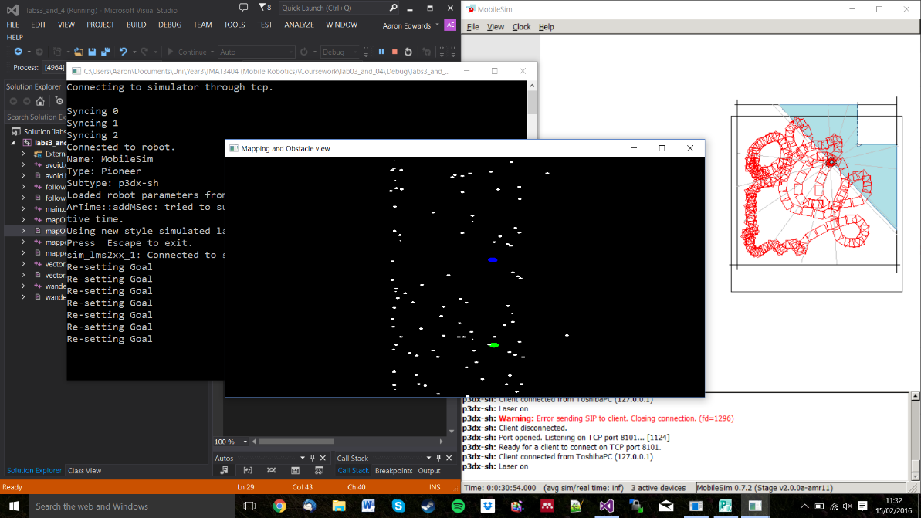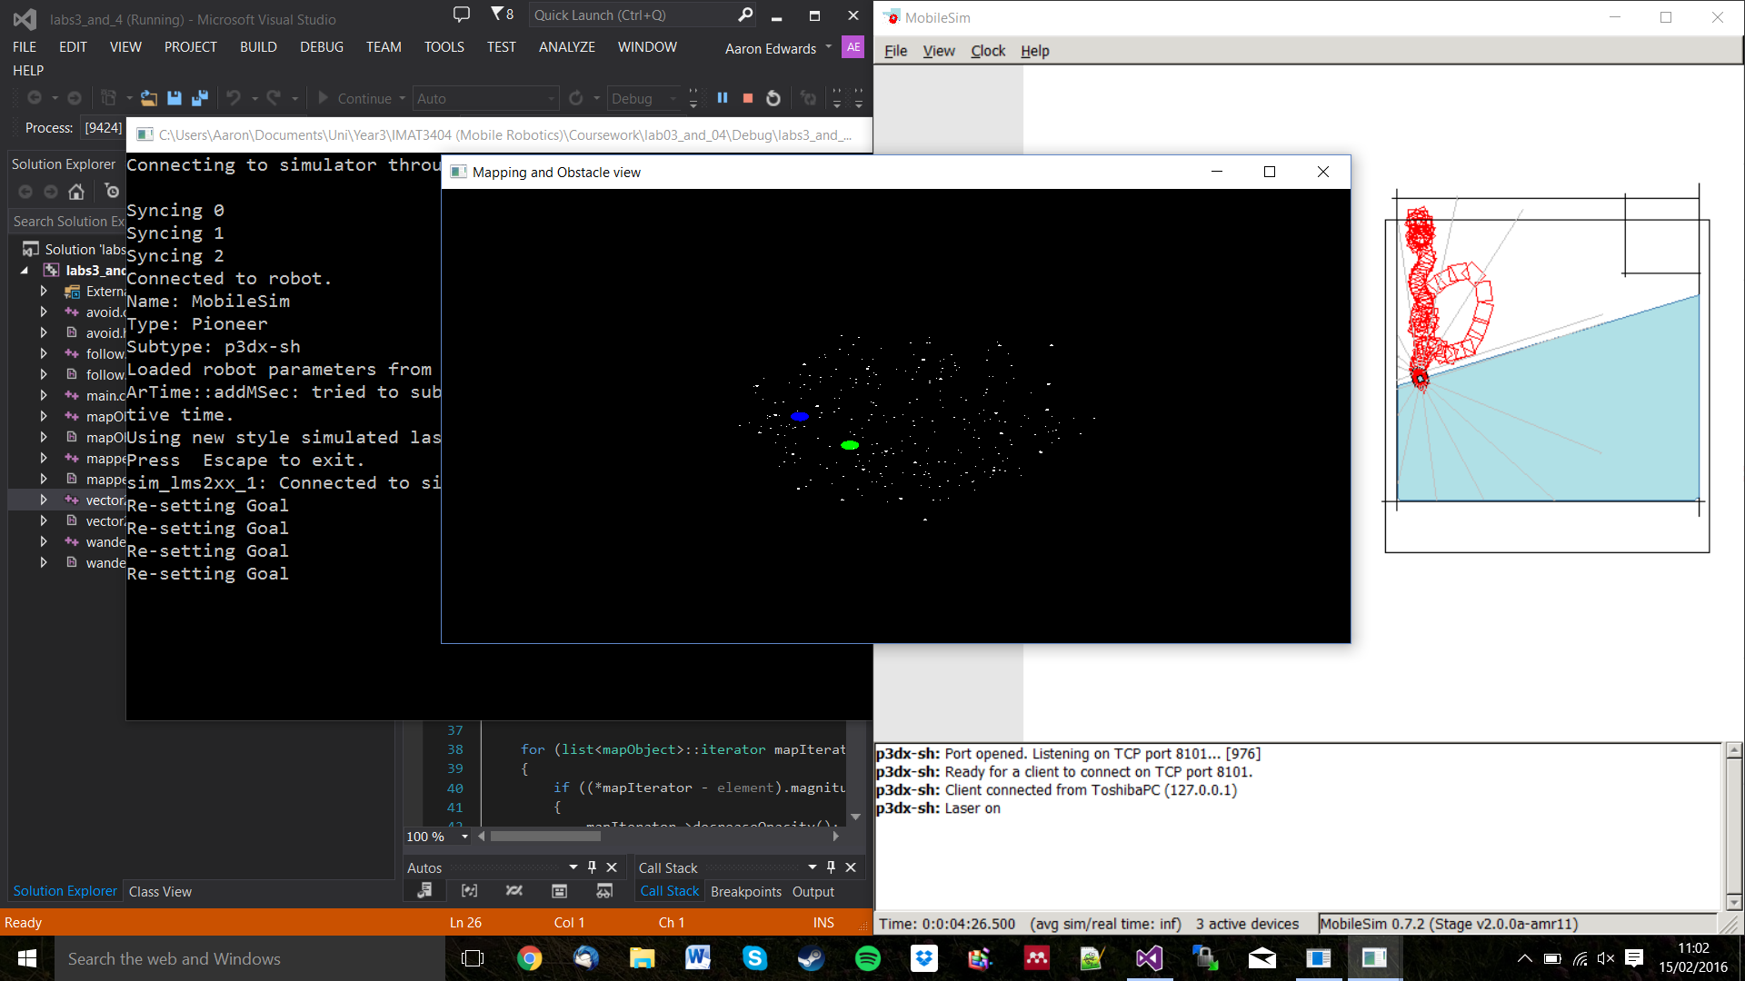

Figure 21 - First Attempts at mapping

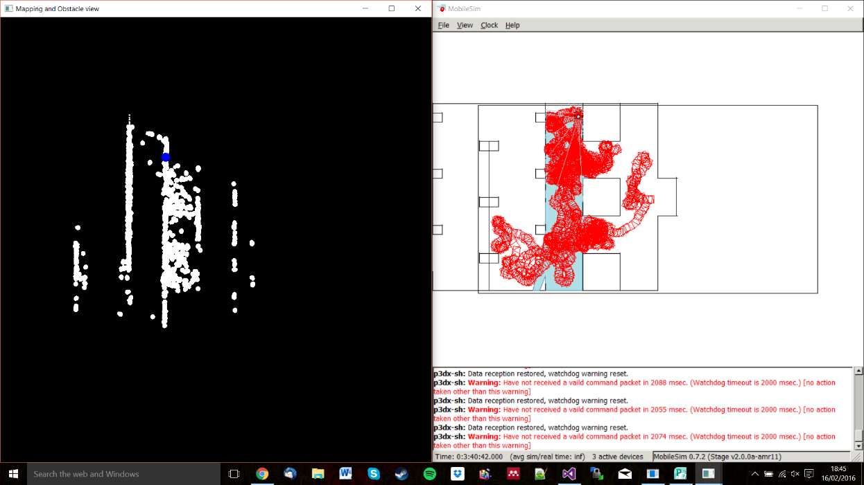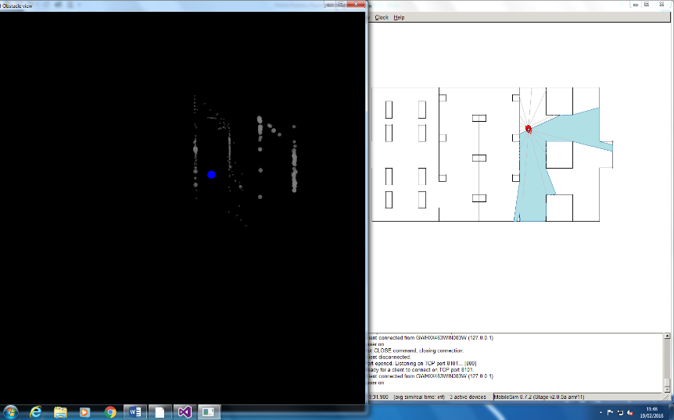

Figure 21 - Testing between variable brightness / radius dependant on certainty of occupancy

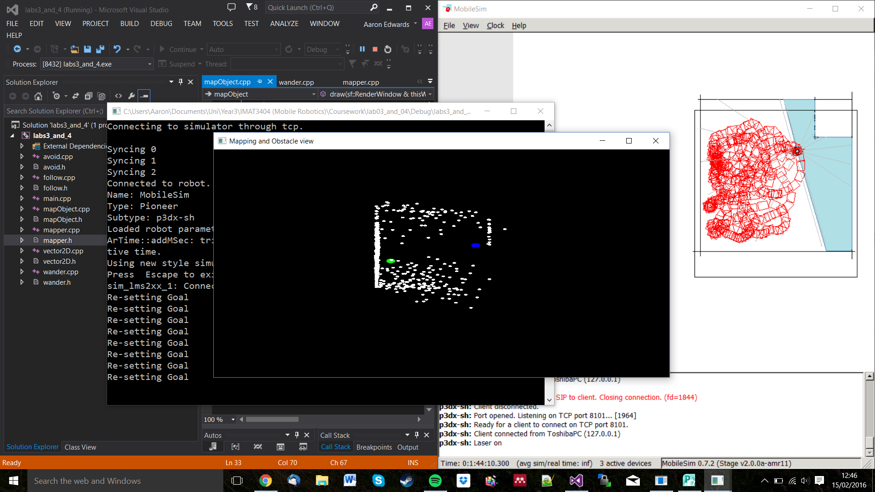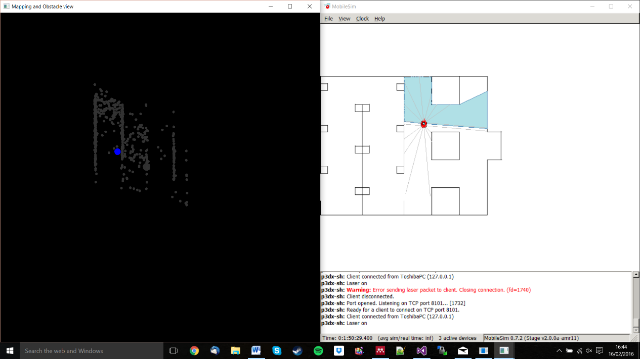

Figure 24 - Early Mapping Attempt, including alternate map

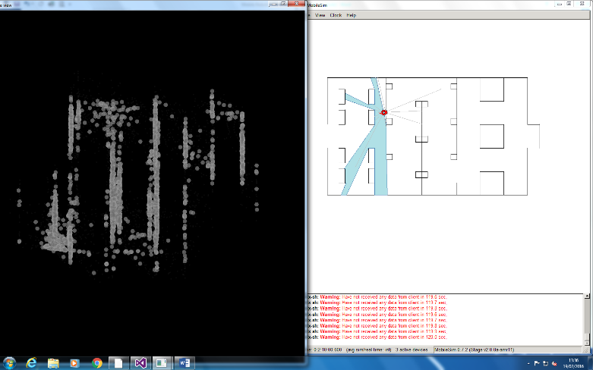

Figure 24 - Higher level of map correction, NOTE: this version contained a bug in the rotation matrix, hence the lack of horizontal lines

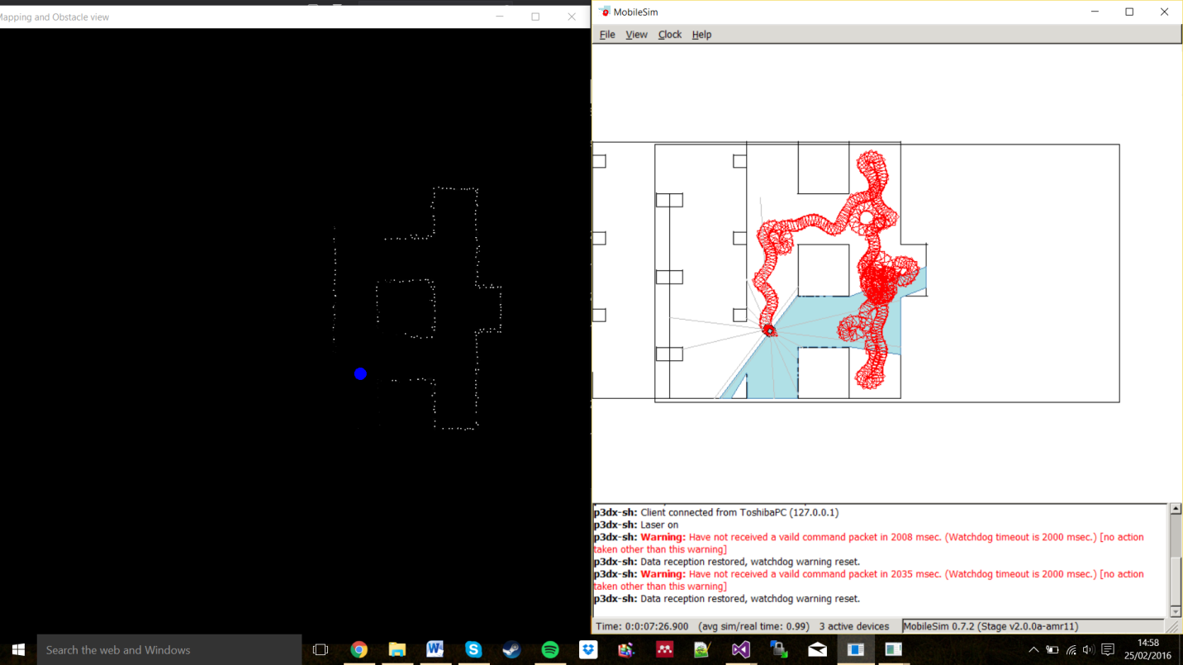

Figure 24- Final Result of mapping